**DAV Final Project**

**Name: Anusha Savaram**

**NET ID: as3444**

**Email ID:** [**as3444@rutgers.edu**](mailto:as3444@rutgers.edu)

**RU ID: 205003732**

**Title: Consumer Segmentation: Know your customer.**

A good understanding of customers is extremely important for running a successful business. KYC (Know your customer) makes a lot of difference for many companies. Customer Analytics is a vital part of marketing Analytics.

‘Customer Segmentation- Know your customer’ is a customer personality Analysis- an attempt to understand the customers, their consumption, spending behavior. We are working on a B2C business model. This dataset is a collection of demographic and psychographic data.

We divide the customers into clusters using k-means clustering and study cluster wise behaviors in terms of the commodity the customer is interested in, age, educational background, marital status, number of children at home (if they are teen or kid), are they virtual or in person buyers or are they loyal consumers of fruits, fish, sweet, gold, do they buy on a discount.

This analysis helps businesses in understanding their customers to customize their products, campaign to select targeted customers with certain number of campaigns. This will cut the Advertisement expenditure significantly and channelize the budget as deemed necessary to increase sales.

This dataset contains **2240 rows and 31 columns** in the data set.

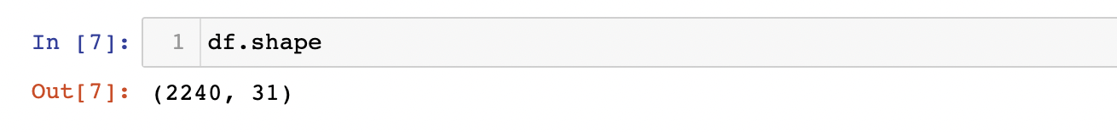

Post dropping **Null values**, there are **2240 rows** and **31 column.**

**Data set in detail**

ID: Customer's unique identifier

Year_Birth: Customer's birth year

Education: Customer's education level

Marital_Status: Customer's marital status

Income: Customer's yearly household income

Kidhome: Number of children in customer's household

Teenhome: Number of teenagers in customer's household

Dt_Customer: Date of customer's enrollment with the company

Recency: Number of days since customer's last purchase

Complain: 1 if customer complained in the last 2 years, 0 otherwise

Products

MntWines: Amount spent on wine in last 2 years

MntFruits: Amount spent on fruits in last 2 years

MntMeatProducts: Amount spent on meat in last 2 years

MntFishProducts: Amount spent on fish in last 2 years

MntSweetProducts: Amount spent on sweets in last 2 years

MntGoldProds: Amount spent on gold in last 2 years

Promotion

NumDealsPurchases: Number of purchases made with a discount

AcceptedCmp1: 1 if customer accepted the offer in the 1st campaign, 0 otherwise

AcceptedCmp2: 1 if customer accepted the offer in the 2nd campaign, 0 otherwise

AcceptedCmp3: 1 if customer accepted the offer in the 3rd campaign, 0 otherwise

AcceptedCmp4: 1 if customer accepted the offer in the 4th campaign, 0 otherwise

AcceptedCmp5: 1 if customer accepted the offer in the 5th campaign, 0 otherwise

Response: 1 if customer accepted the offer in the last campaign, 0 otherwise

Place

NumWebPurchases: Number of purchases made through the company’s web site

NumCatalogPurchases: Number of purchases made using a catalogue

NumStorePurchases: Number of purchases made directly in stores

NumWebVisitsMonth: Number of visits to company’s web site in the last month

**Table: Attribute Information**

|  |  |  |  |
| --- | --- | --- | --- |
| **Attribute Name** | **Attribute Description** | **Data Type** | **Units** |
| **ID** | **Customer's unique identifier** | **Integer** | **NA** |
| **Year_Birth** | **Customer's birth year** | **Integer** | **NA** |
| **Education** | **Customer’s education level** | **Object** | **NA** |
| **Marital_Status** | **Customer’s marital status** | **Object** | **No Units** |
| **Income** | **Customer’s yearly household income** | **Float** | **USD** |
| **Kidhome** | **Number of children in customer’s household** | **Integer** | **NA** |
| **Teenhome** | **Number of teenagers in customer’s household** | **Integer** | **NA** |
| **Dt_Customer** | **Date of customer’s enrollment with the company** | **Object** | **NA** |
| **Recency** | **Number of days since customer's last purchase** | **Integer** | **Days** |
| **Complain** | **1 if customer complained in the last 2 years, 0 otherwise** | **Integer** | **Boolean** |
| **MntWines** | **Amount spent on wine in last 2 years** | **Integer** | **USD** |
| **MntFruits** | **Amount spent on fruits in last 2 years** | **Integer** | **USD** |
| **MntMeatProducts** | **Amount spent on meat in last 2 years** | **Integer** | **USD** |
| **MntFishProducts** | **Amount spent on sweets in last 2 years** | **Integer** | **USD** |
| **MntSweetProducts** | **Amount spent on sweets in last 2 years** | **Integer** | **USD** |
| **MntGoldProds** | **Amount spent on gold in last 2 years** | **Integer** | **USD** |
| **NumDealsPurchases** | **Number of purchases made with a discount** | **Integer** | **NA** |
| **AcceptedCmp1** | **1 if customer accepted the offer in the 1st campaign, 0 otherwise** | **Integer** | **Boolean** |
| **AcceptedCmp2** | **1 if customer accepted the offer in the 2nd campaign, 0 otherwise** | **Integer** | **Boolean** |
| **AcceptedCmp3** | **1 if customer accepted the offer in the 3rd campaign, 0 otherwise** | **Integer** | **Boolean** |
| **AcceptedCmp4** | **1 if customer accepted the offer in the 4th campaign, 0 otherwise** | **Integer** | **Boolean** |
| **AcceptedCmp5** | **1 if customer accepted the offer in the 5th campaign, 0 otherwise** | **Integer** | **Boolean** |
| **Response** | **1 if customer accepted the offer in the last campaign, 0 otherwise** | **Integer** | **Boolean** |
| **NumWebPurchases** | **Number of purchases made through the company’s web site** | **Integer** | **NA** |
| **NumCatalogPurchases** | **Number of purchases made using a catalogue** | **Integer** | **NA** |
| **NumStorePurchases** | **Number of purchases made directly in stores** | **Integer** | **NA** |
| **NumWebVisitsMonth** | **Number of visits to company’s web site in the last month** | **Integer** | **NA** |

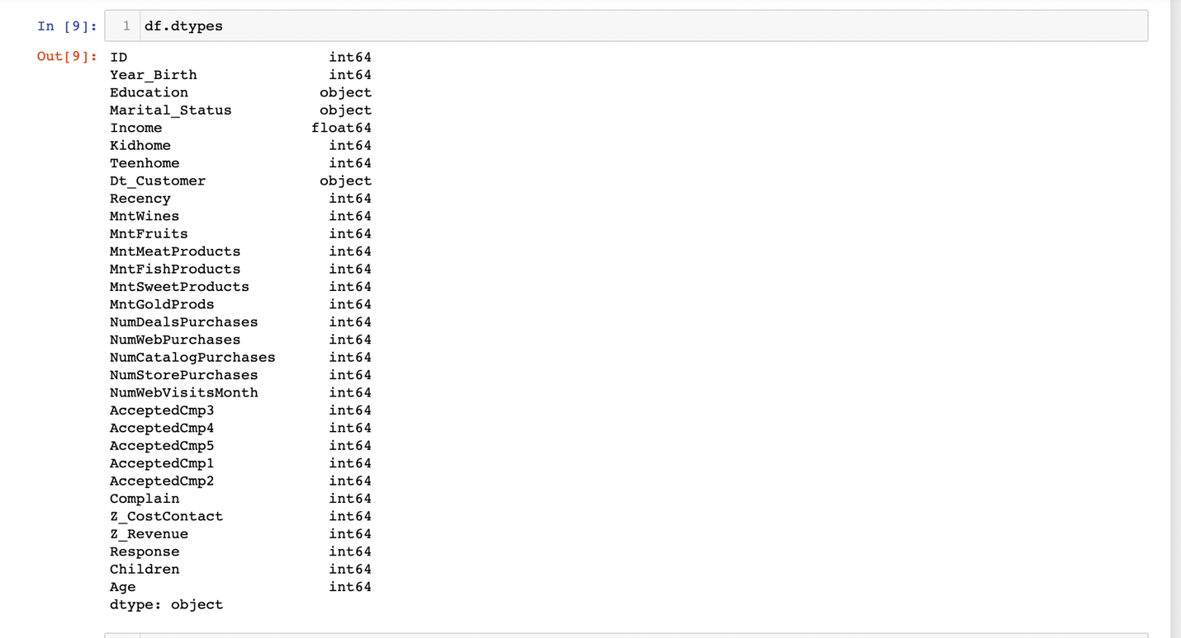

**Null values check**

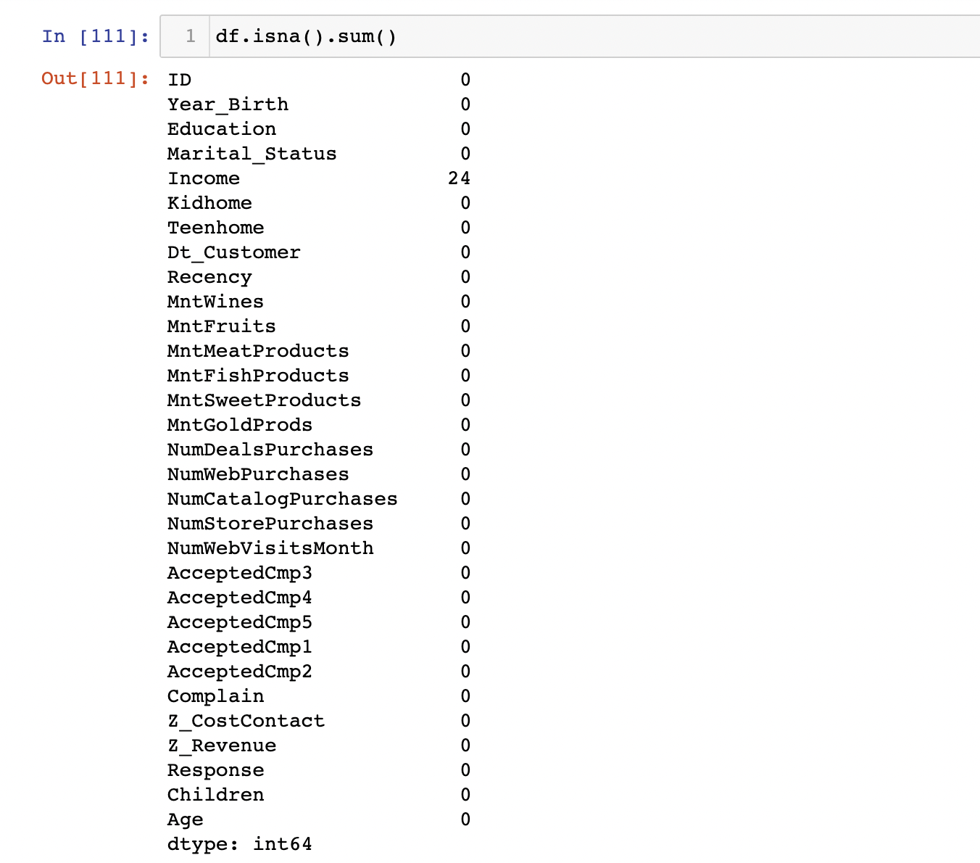

There are currently 2240 rows and 31 columns. We now drop rows with 24 null values from income.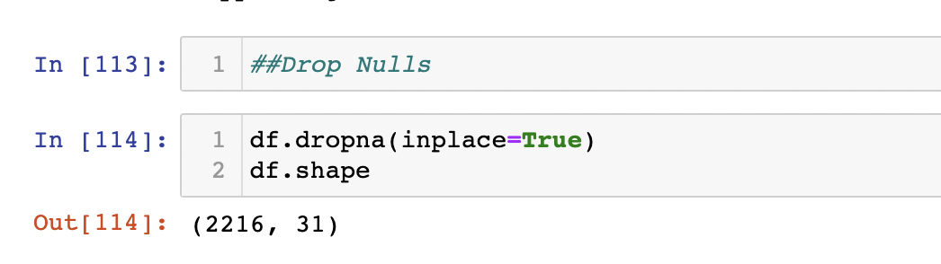

2240-24=2216, therefore the data frame with 2216 rows and 31 columns is null value free.

Data Type Change

We then changed Marital_Status which is an object data type to categorical variable. We change it into categorical variable to pass the data to machine learning prediction.

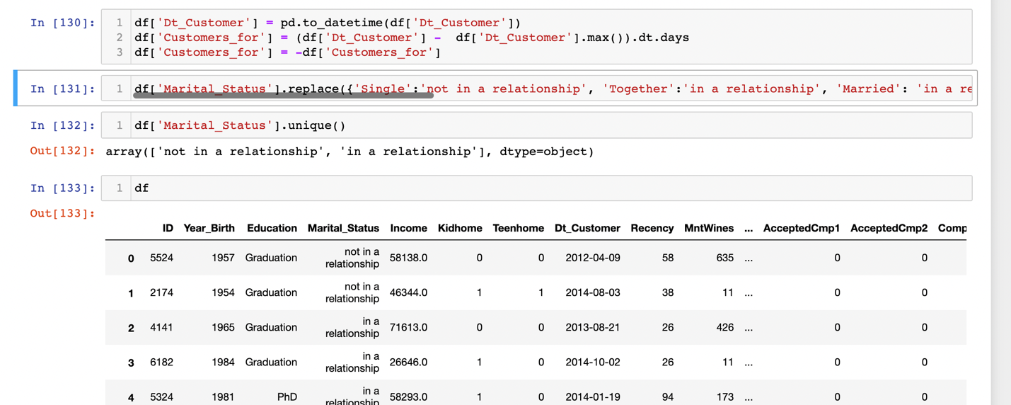

* Both teenagers and kids constitute children.

df["Children"] = df["Kidhome"] + df["Teenhome"]

**Count Plot: Family size stat: No. of customer vs children count -Chart 1**

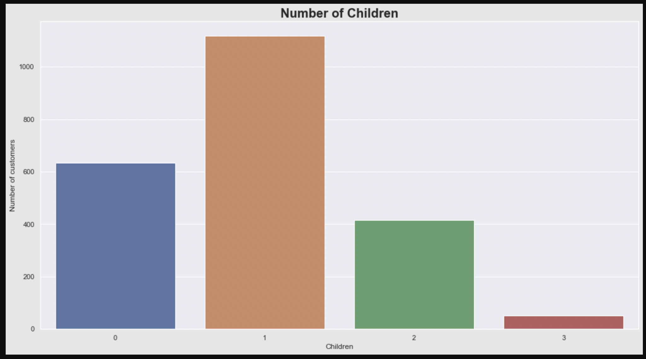

**Majority of the customers have single child or no children. Hardly customers have 3 children.**

**Count Plot: Customer Age Stats – Chart 2**

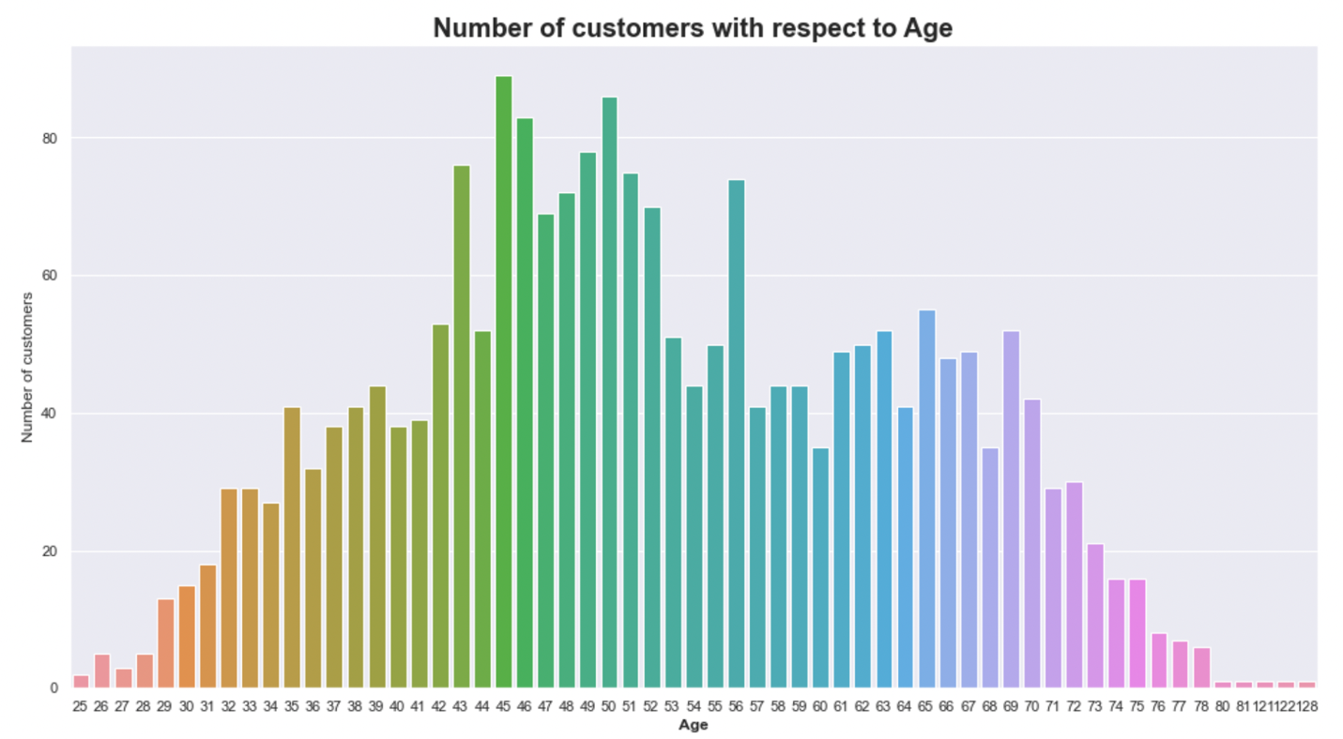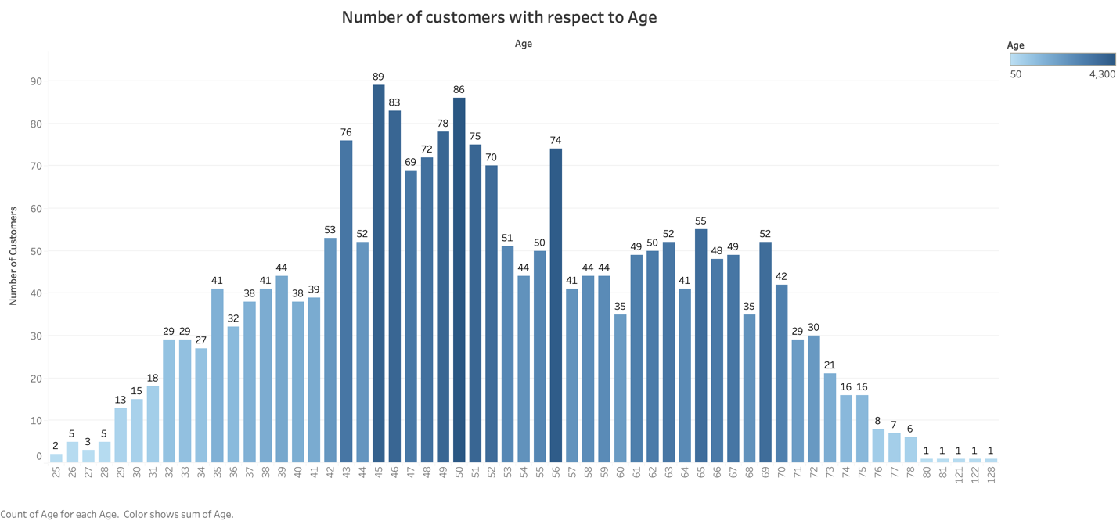

**Most of the customers who purchase are middle aged.**

**Let us know more about what type of people come to purchase.**

**Count Plot: Customer’s Educational Background – Chart 3**

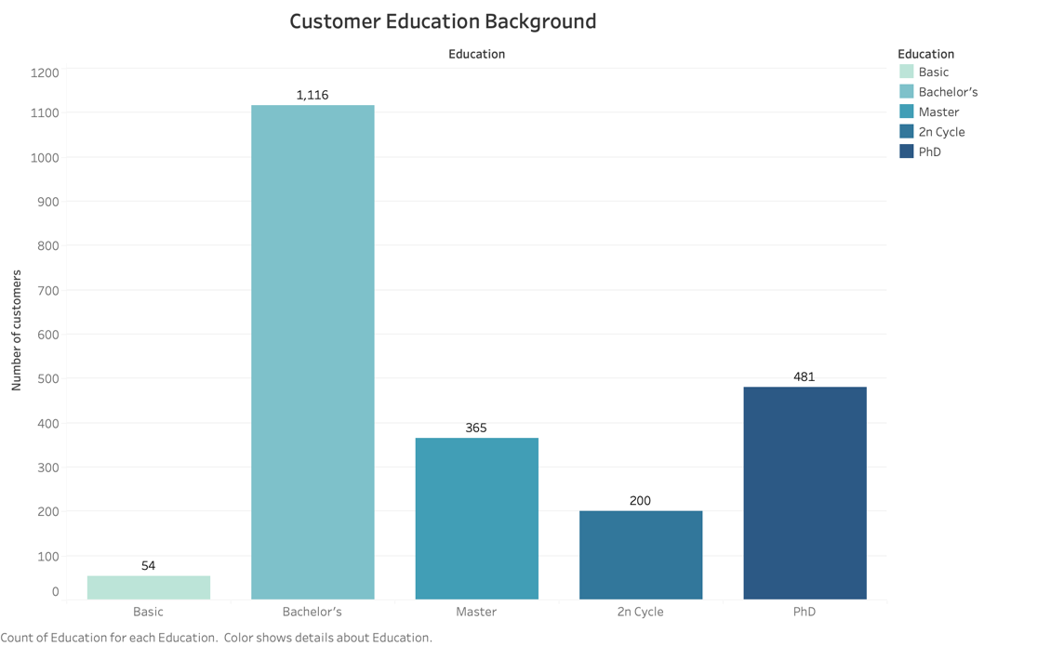

**Large number of customers with Bachelor’s degree as highest qualification make purchase.**

**Bubble Chart: An account of education and income, spending of customers – Chart 4**

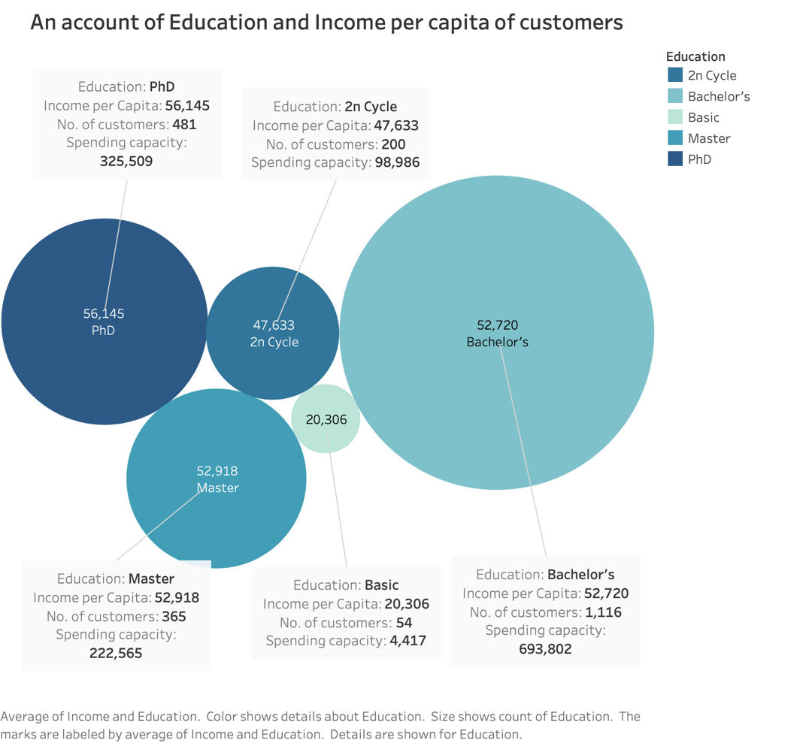

**Income per capita: Basic<2ncycle<Bachelor’s<Master’s<PhD**

**Number of customers: Bachelor’s>PhD>Masters’s>2ncycle>Basic. => Progressive society**

**Spending: Bachelor’s >PhD>>Masters 2ncycle>Basic**

Bachelor’s are spending more despite of relatively less income than PhD and Master’s

The income trend is as expected. Income increases as educational level increases.

**Box Plot: Age of customers with their educational background – Chart 5**

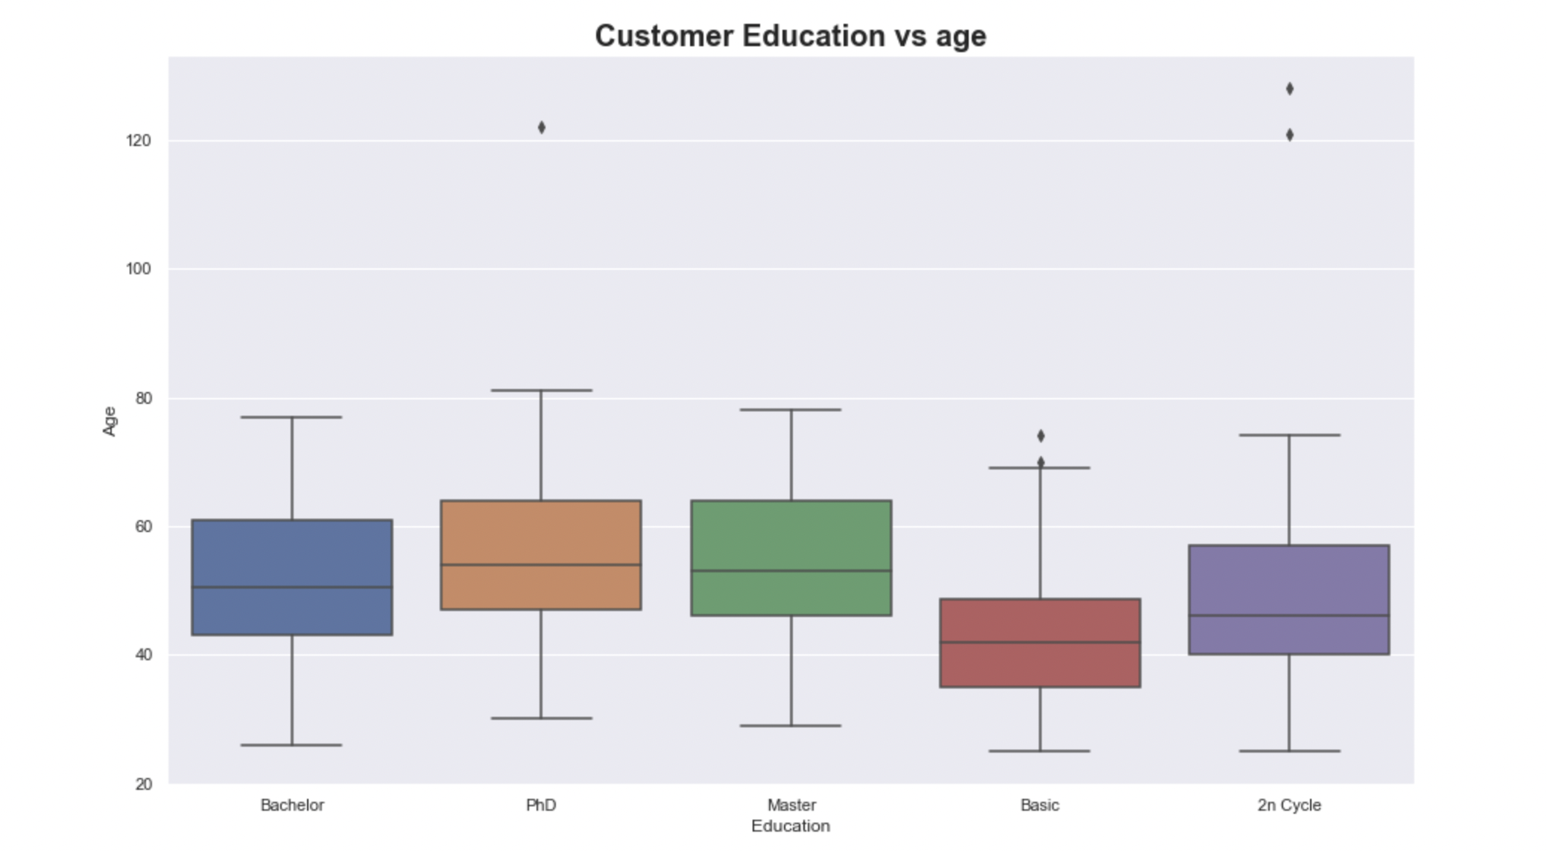

**There are few outliers for PHD and 2n Cycle. Majority of the customers have graduation, PhD, Master’s background. They are aged around 50 years. Customers with basic educational background are one of the youngest ones.**

**Count Plot: No. of customers categorized by Marital Status – Chart 6**

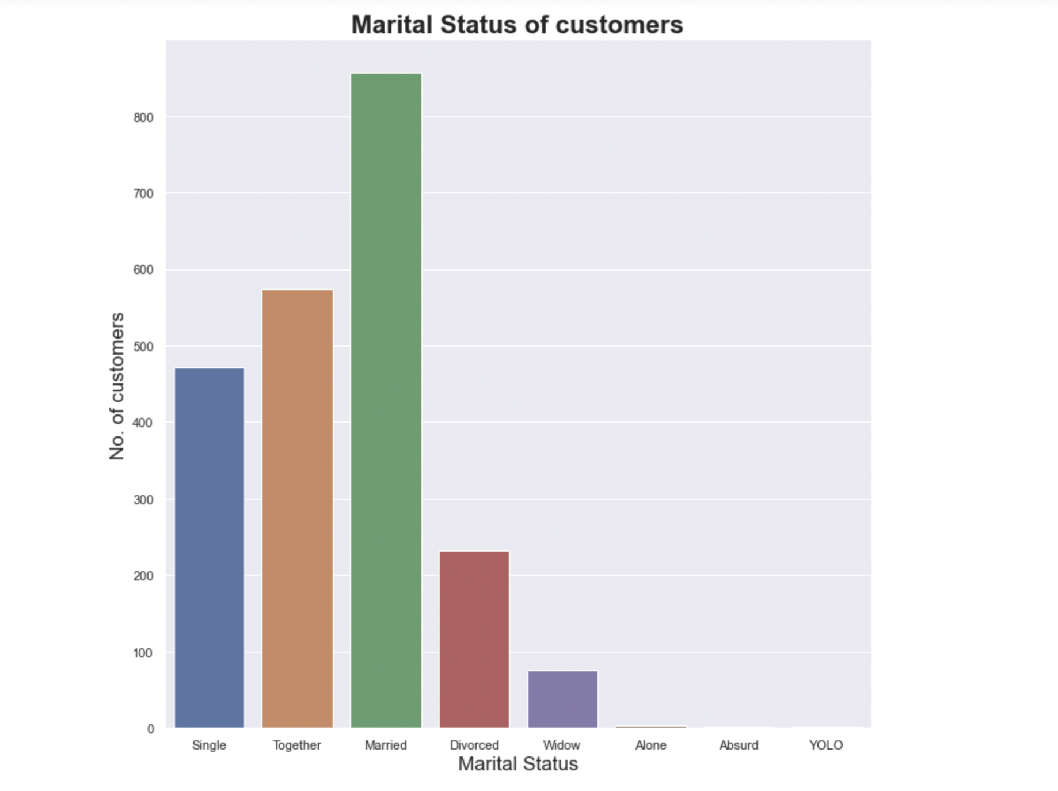

**Majority of customers of this company are married couples.**

**Correlation: Income vs Education – Chart 7**

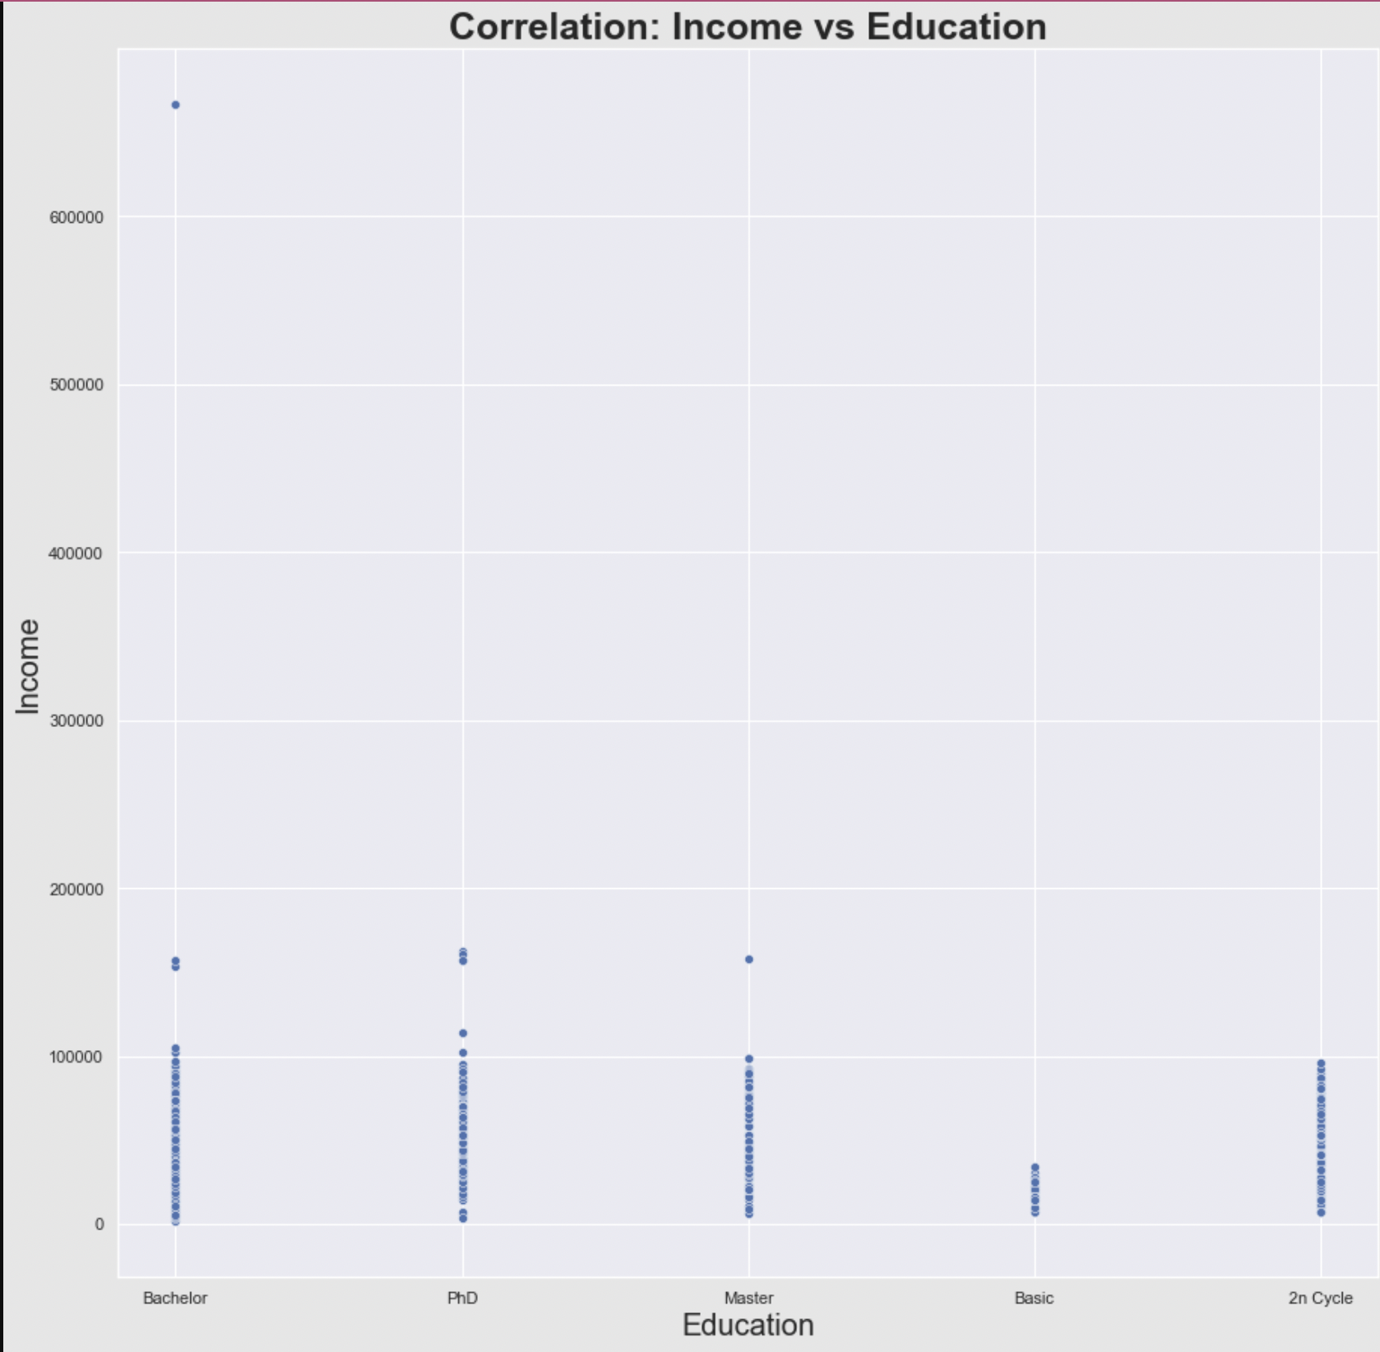

**Customers with basic education background earn least, while those with 2n Cycle degree experience increase in income as they get older (or gain more experience).**

**Bar Graph: Spend Trend with respect education background– Chart 8**

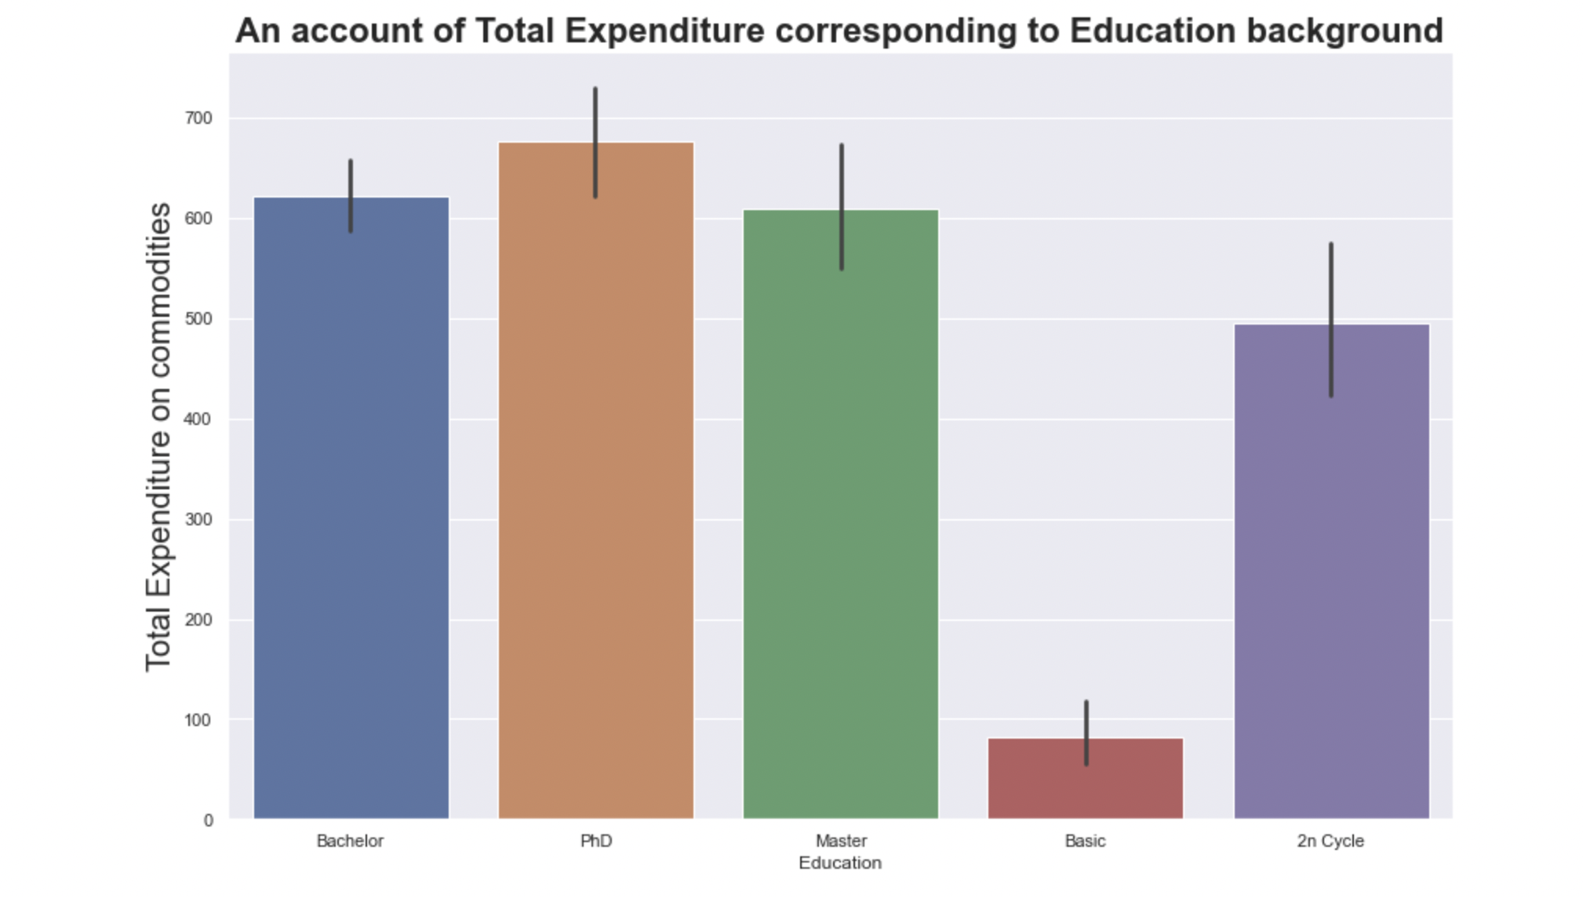

**Customers with PhD background have higher spending pattern over others. Customers with basic educational background spend the least. Customers with higher educational background earn higher and hence tend to spend higher. They have higher spending capability. Ironically 2ncycle is defying this hypothesis with total buy below graduation, PhD, and Master’s.**

**This could be due to the fact (from Box plot: Chart 5) that 2n cycle has customers from lower age group (hence lesser material requirement) in comparison to Graduation, PhD and master’s students.**

**Box Plot: Number of Children vs Customer’s Income – Chart 9**

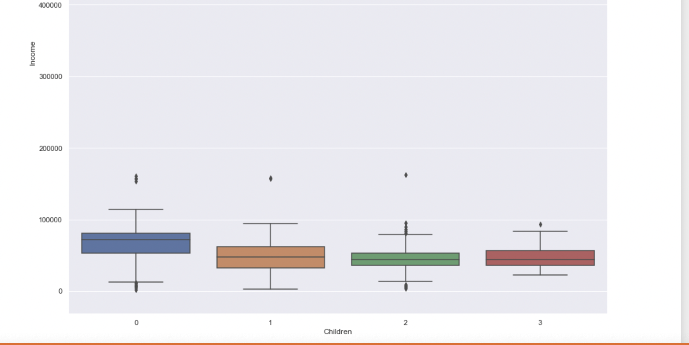

**The above box plot highlights the fact that customers with no children have higher income. This could be due to a fact that customers with no children got time and energy to focus on their professional growth and earn bucks. Number of outliers for all the 4 categories are significantly low.**

**Customers with 3 children earn fairly low over customers with 0,1,2 children.**

**Income (No Children)> Income ( 1 Child)> Income (2 Children)> Income (3 children)**

**Box Plot: Spend Trend with and without Children – Chart 10**

**We change Children variable into categorical.**



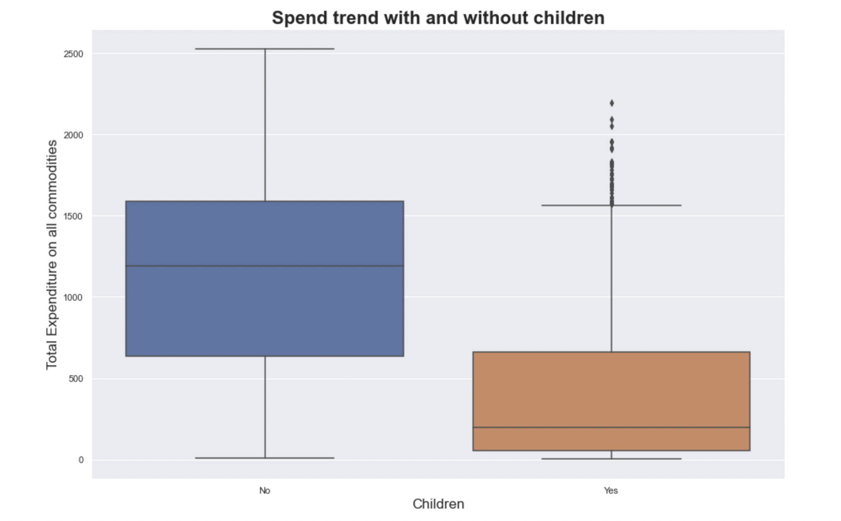

**Customers with no children have higher variation in spend trend and customers with children have outliers but usually spend lower than the customers who have no children.**

**Box Plot: No. of children vs Total Expenditure -Chart 11**

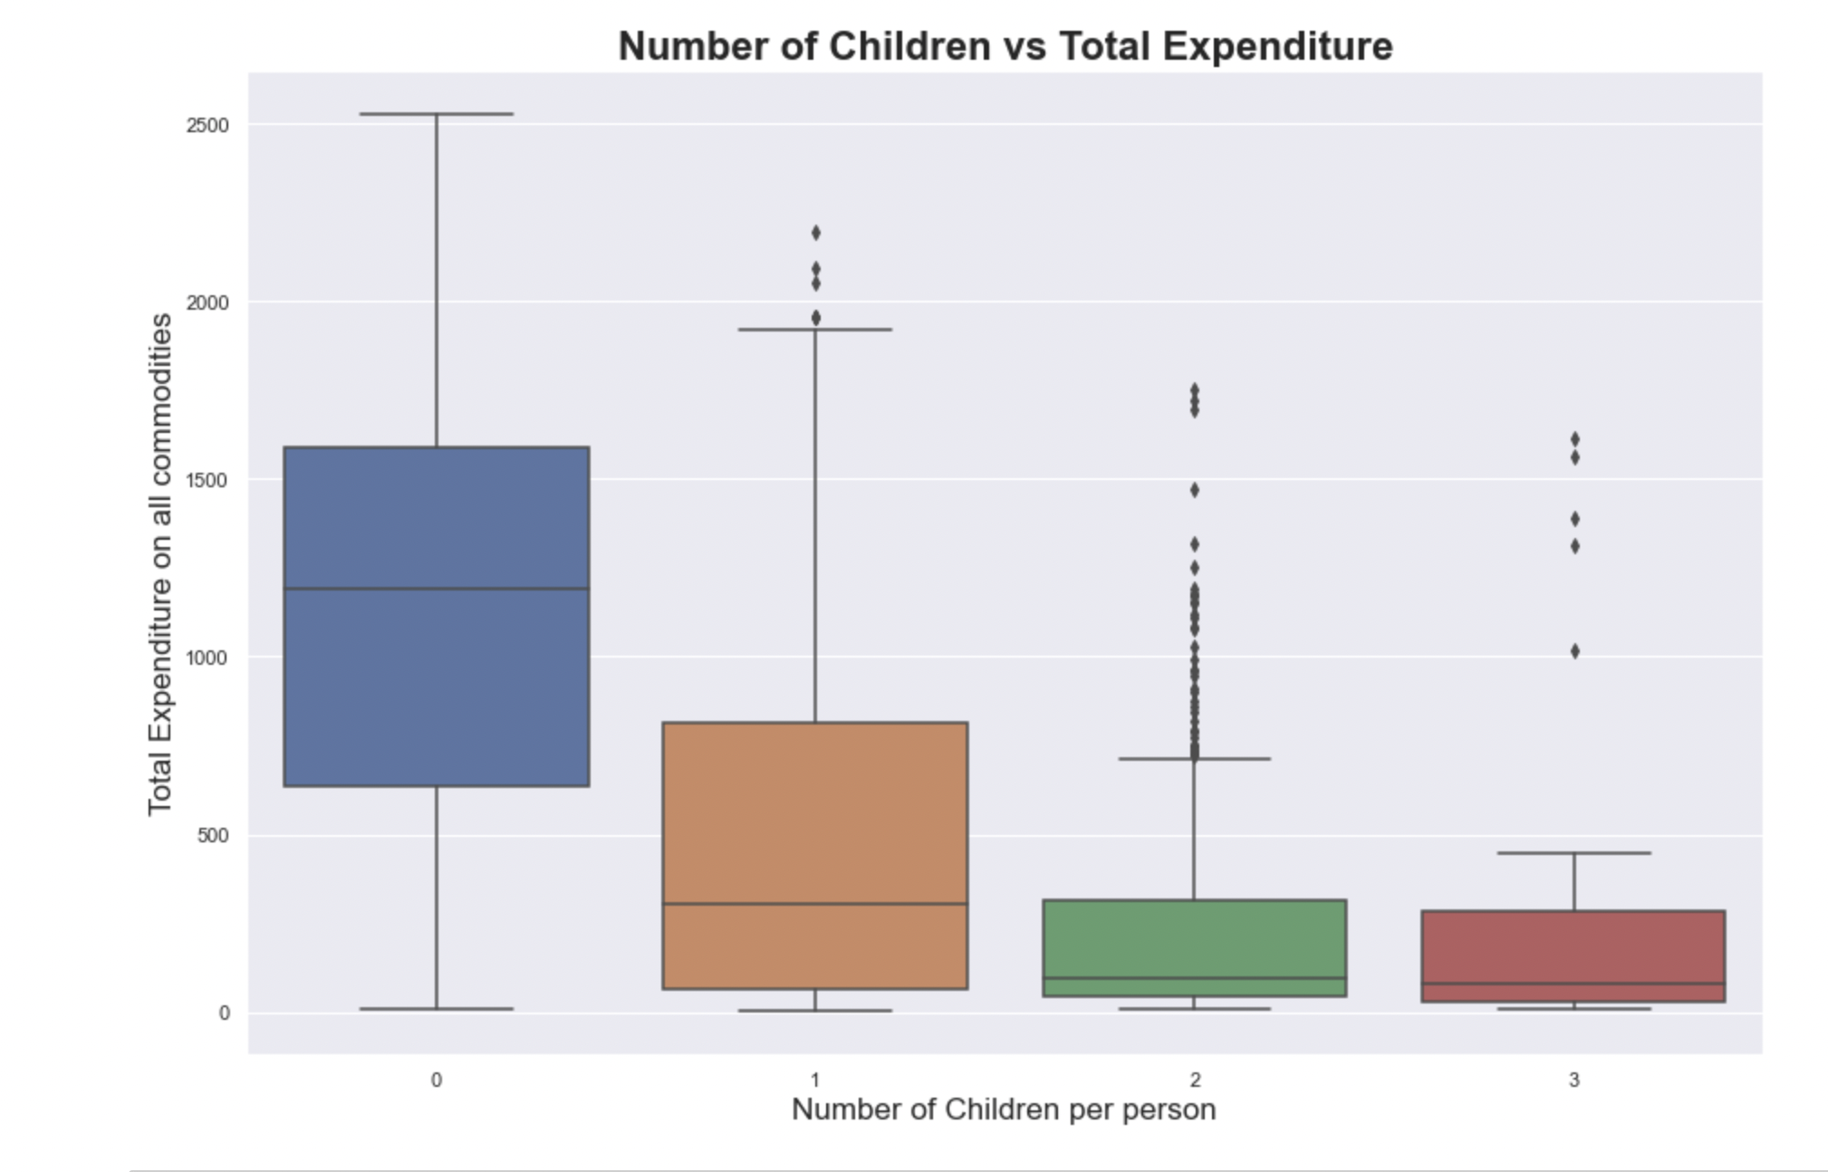

**Pie Chart: Complains-Chart 12**

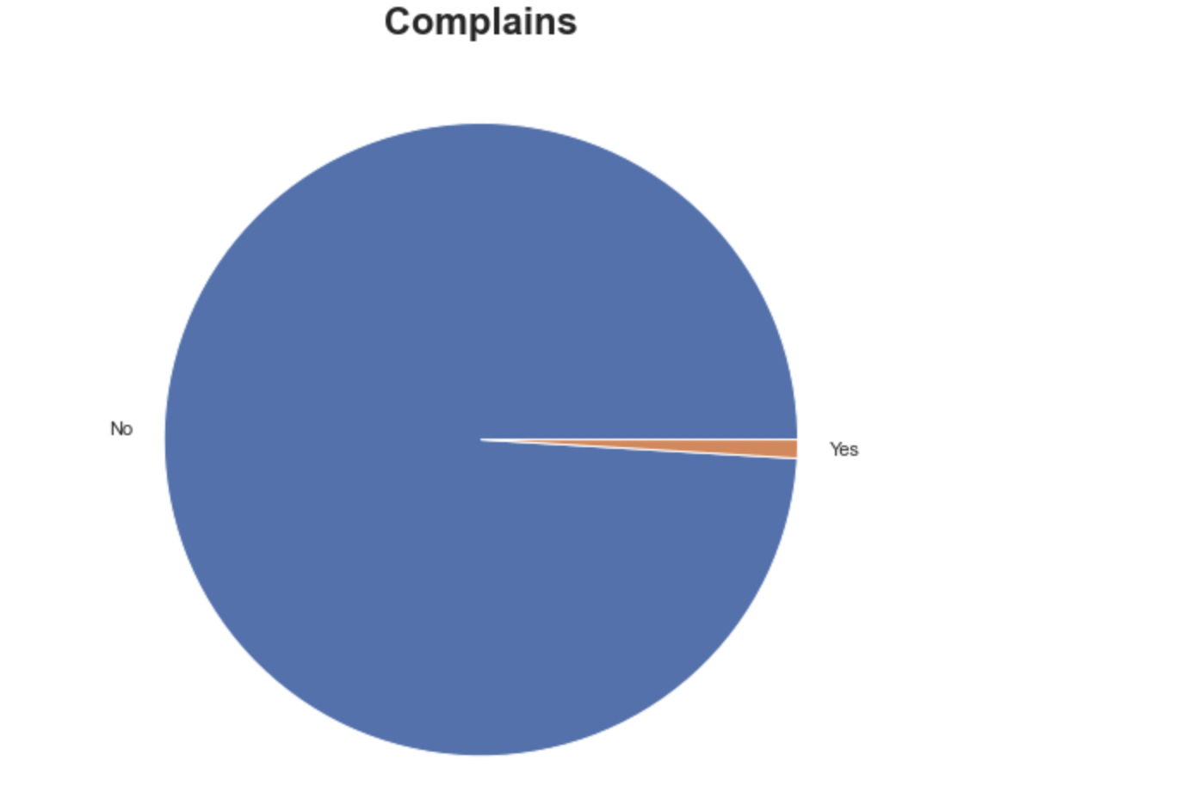

**This company is doing a great job in maintaining customer satisfaction. There are hardly any complains.**

**Pie Chart: Total Purchases categorized by forum of purchase- Chart 13**

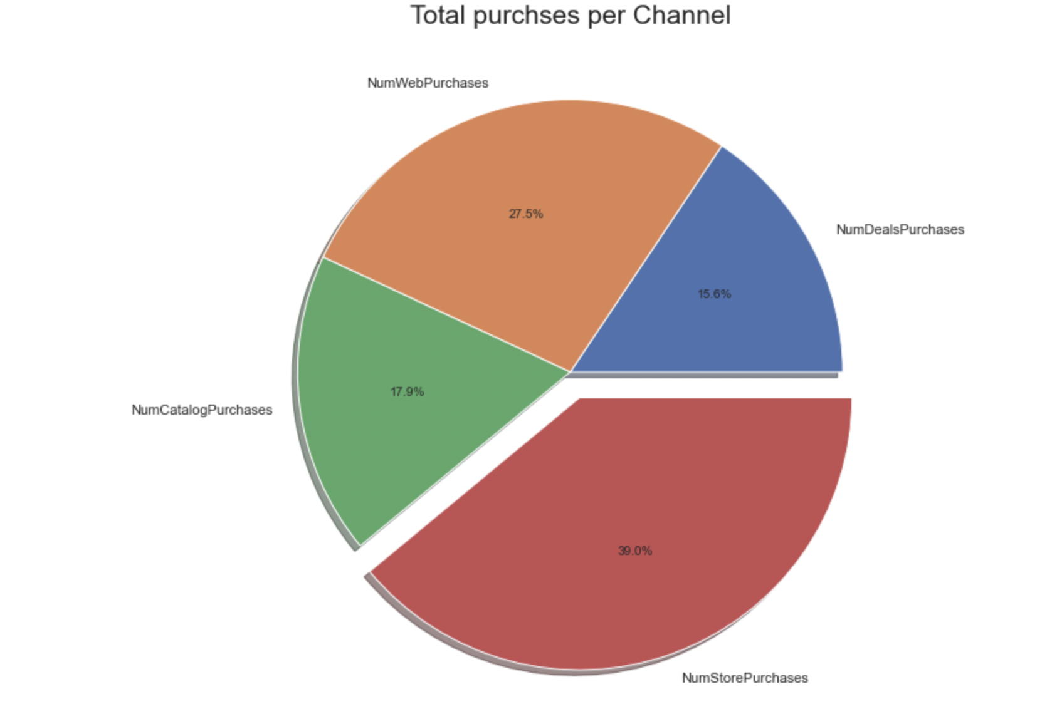

**Customers of this company usually prefer to make store purchases followed by web purchases. Customers don’t purchase on discount much.**

**Count Plot: Customer Response to Discounts- Chart 14**

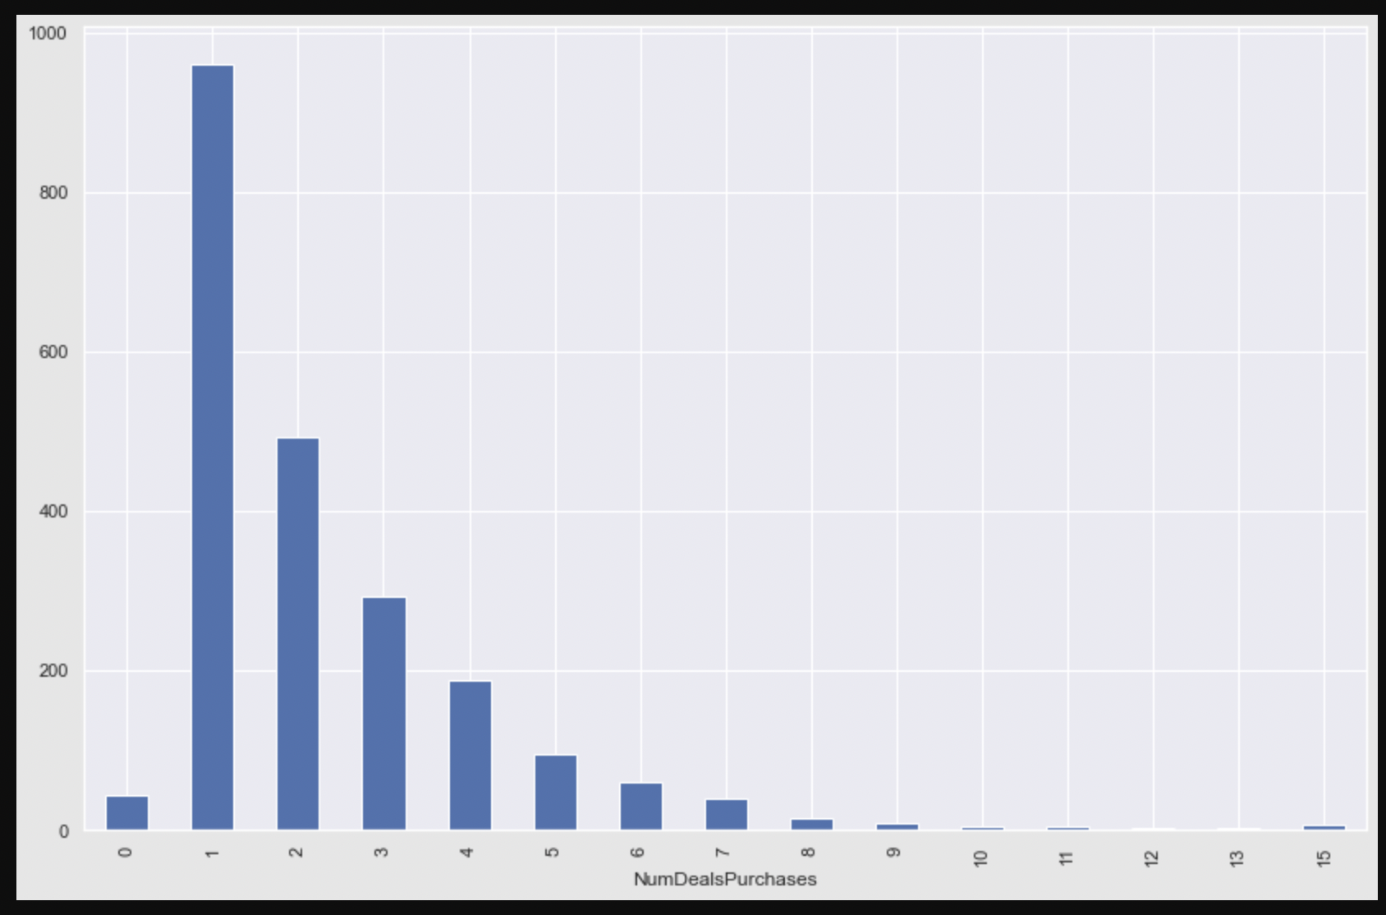

**The above count plot clearly shows that large number of customer use at max one discount. Discounts used by a single customer is dropping down from 2 discounts to 10 discounts. There are hardly any customer is using 15 discounts.**

**Count Plot: Customer Response to Store sale- Chart 15**

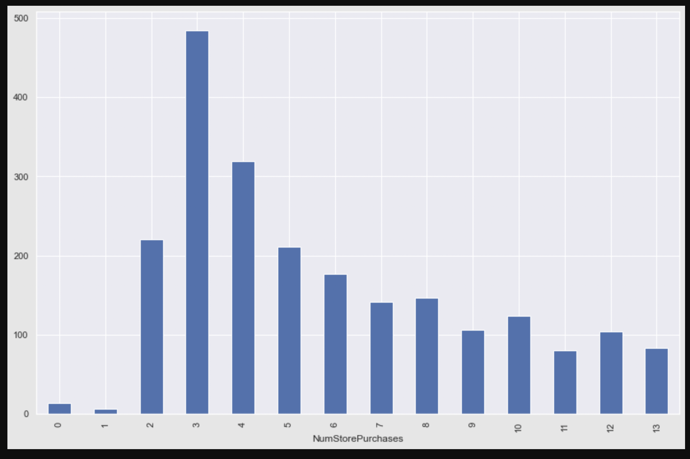

**Customers with 3 store purchases are the highest followed by 4 and 2.**

**Count Plot: Monthly web visits Chart 16**

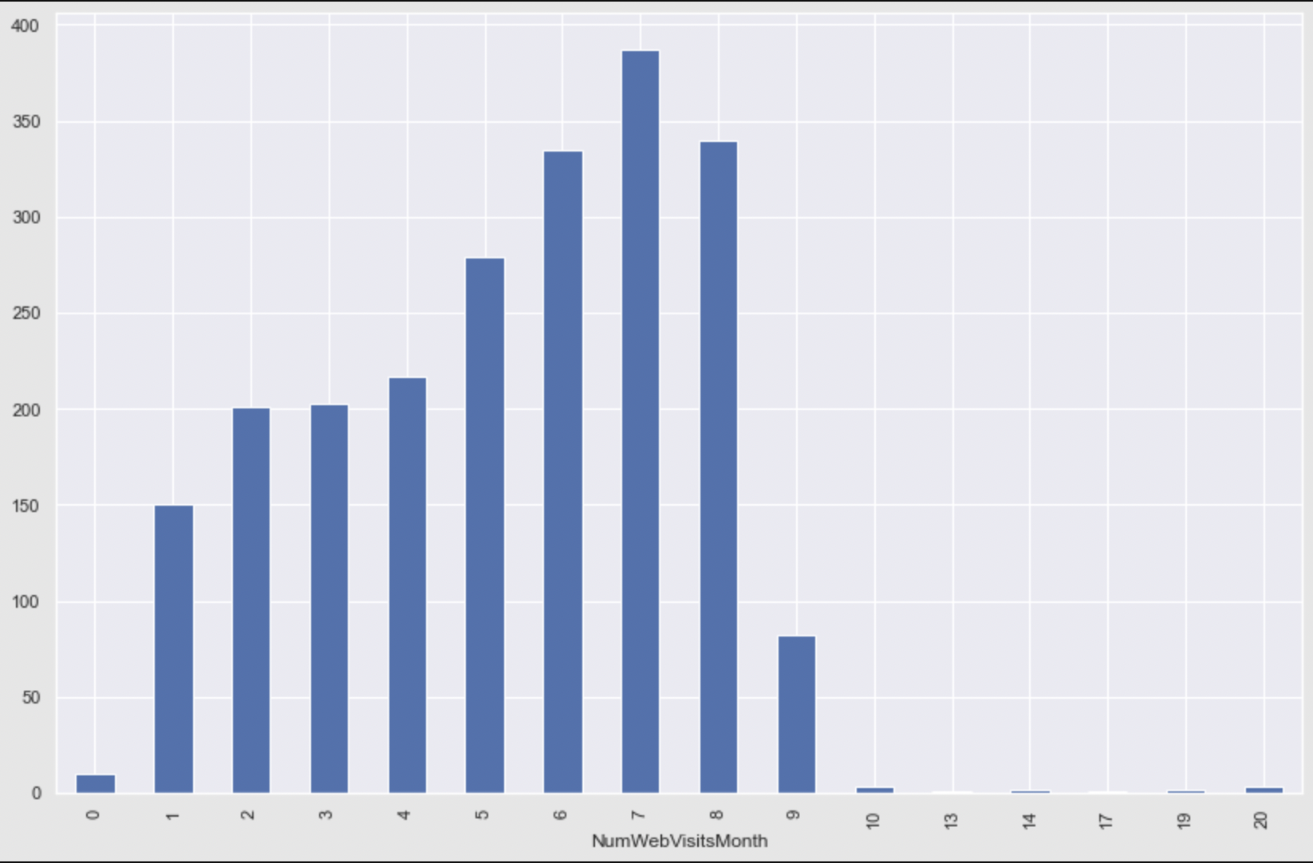

**Customers usually hit company website 7 times.**

**Count Plot: Customers on catalog purchases- Chart 17**

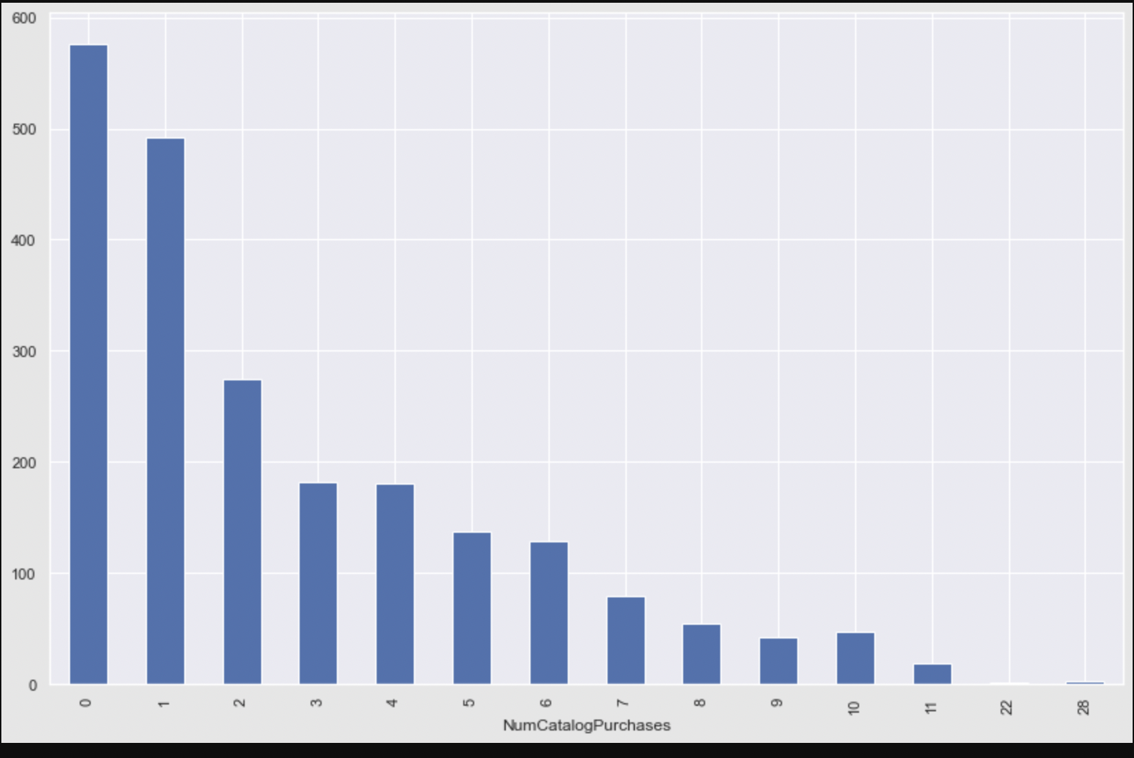

**This graph shows that catalog purchases are generally not preferred, this could be because of the commodity range restrictions. Highest number of catalog purchases is 28.**

**Count Plot: Customer Response to e-commerce- Chart 18**

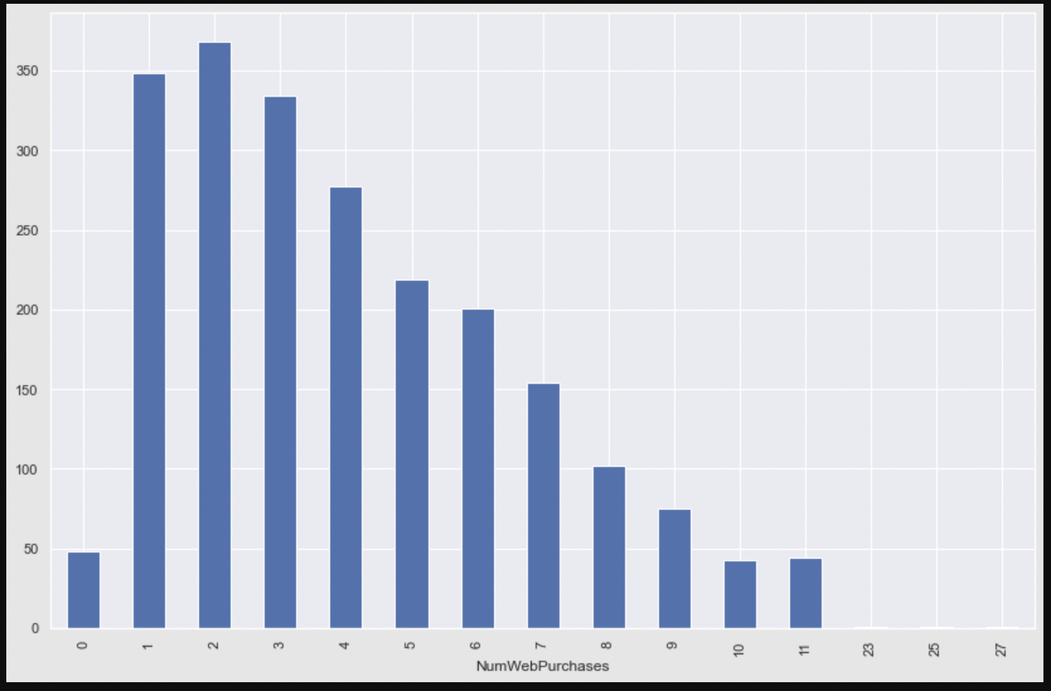

**On average a customer makes 1 to 4 web purchases. This is a 2015 data. So ,internet might not be widely used. The count would have surely gone up if it was current data.**

**Preparing the data for visualization**

There are less number of customers who accept distance especially during the initial campaign. We are trying to understand the number of customers who respond to discounts offered by the company.

df['Total_discount_acpt'] = df['AcceptedCmp1'] + df['AcceptedCmp2'] + df['AcceptedCmp3'] + df['AcceptedCmp4'] + df['AcceptedCmp5']

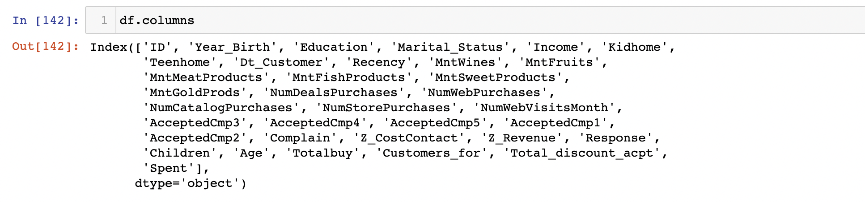

The names of attributes are a not self-explanatory. So let us rename them.

df.rename(columns={'MntWines': 'Wines', 'MntFruits': 'Fruits', 'MntMeatProducts': 'Meat', 'MntFishProducts': 'Fish', 'MntSweetProducts': 'Sweet', 'MntGoldProds': 'Gold'}, inplace = True)

df.rename(columns={'NumDealsPurchases': 'DealsPurchases', 'NumWebPurchases': 'WebPurchases', 'NumCatalogPurchases': 'CatalogPurchases', 'NumStorePurchases': 'StorePurchases', 'NumWebVisitsMonth': 'WebVisitsMonth'}, inplace = True)

We drop columns that we think are not necessary for visualization by having a copy of original dataset.

df.drop(['Year_Birth', 'Kidhome', 'Teenhome', 'Dt_Customer', 'Z_CostContact', 'Z_Revenue', 'AcceptedCmp1', 'AcceptedCmp2', 'AcceptedCmp3', 'AcceptedCmp4', 'AcceptedCmp5', 'Response'], inplace = True, axis = 1)

Let us plot correlation to further understand the variables.

**Correlation Chart between variables-Chart 19**

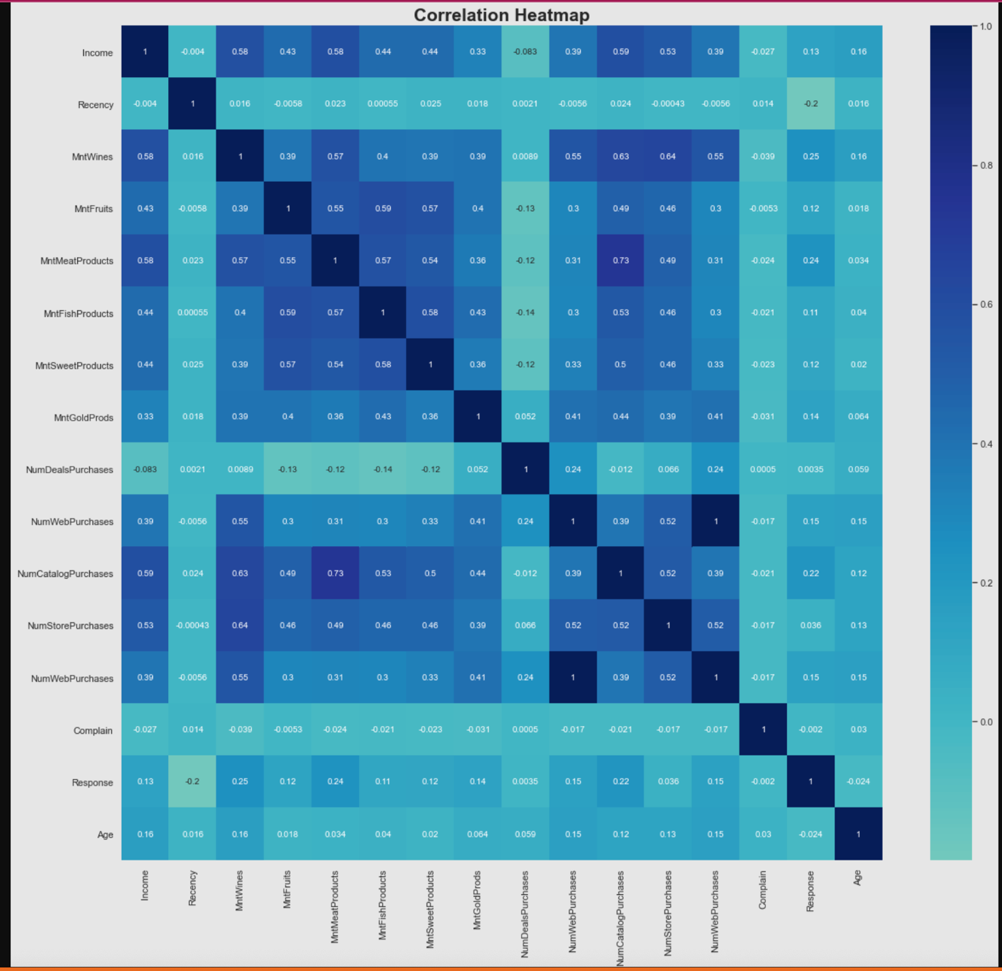

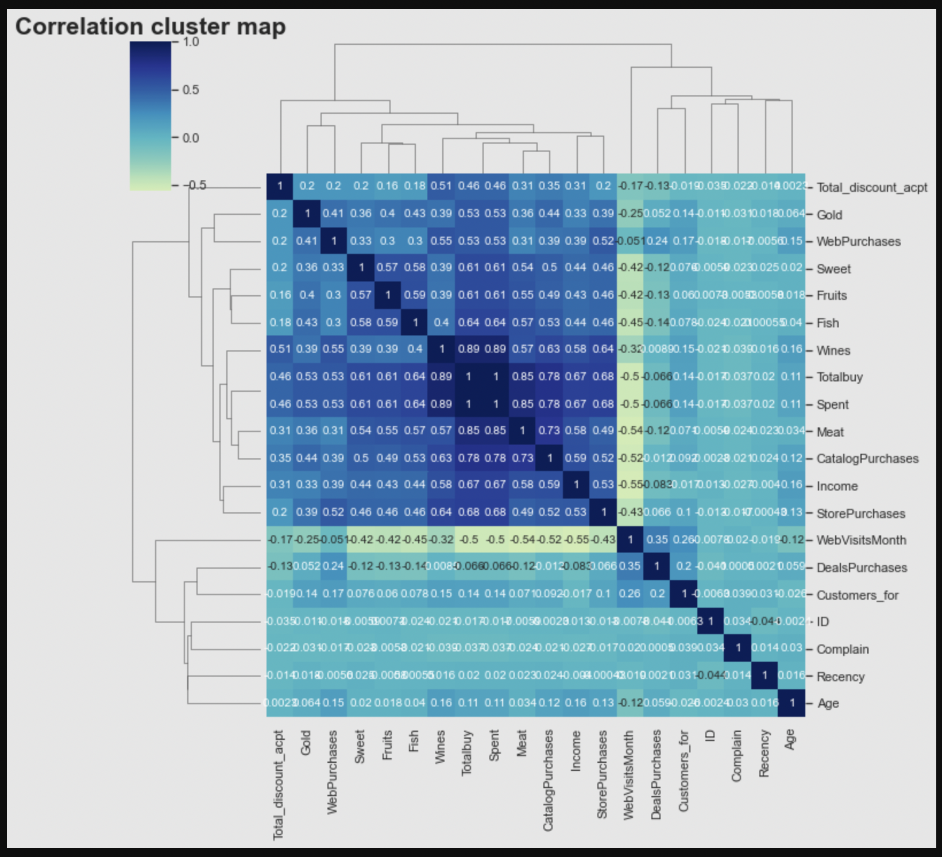

**There is no multicollinearity (Correlation value>0.7). So, we cannot drop any column henceforth.**

Below are the attributes under consideration for final dataset.

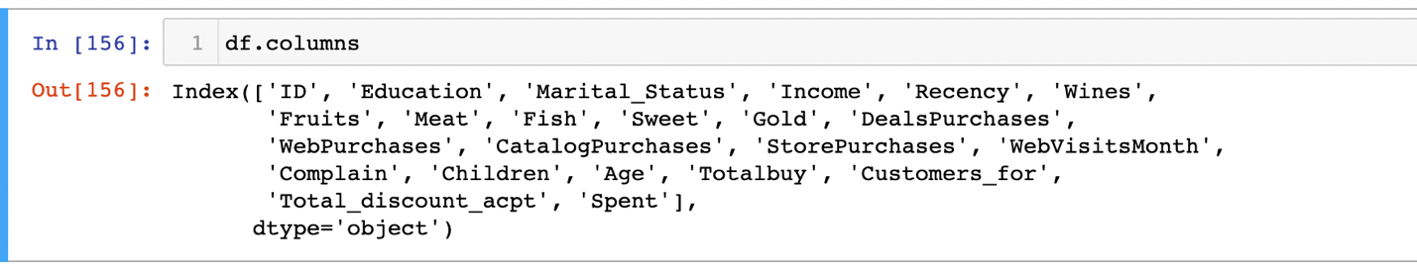

**We write our dataframe into a CSV**

**df.to_csv('/Users/anusha._s/Desktop/Rutgers/Sem 1/DAV/Assignment 5/Customer Behaviour Analysis.csv')**

Machine Learning models except NLP take only values and not strings. So we convert categorical values like Children and marital status into numerical values.

We further prepare the dataset to send it to machine learning using standard scaler and perform a 30% dimensional reduction using Principle component Analysis (PCA)

**Choosing k value in K-Means - Chart 20**

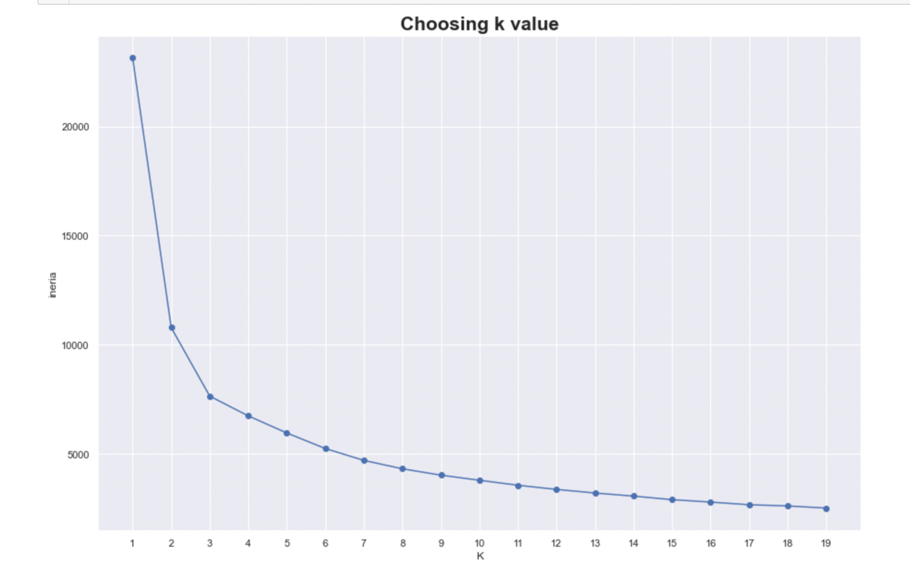

We used inertia to choose our k value. Ideal k value is the one with lower k value and inertia. We can see that k=3 is point where graph is dropping. Hence we choose to make 1 to 3 .i.e., 4 clusters

**Count Plot: Number of customers in each customer- Chart 21**

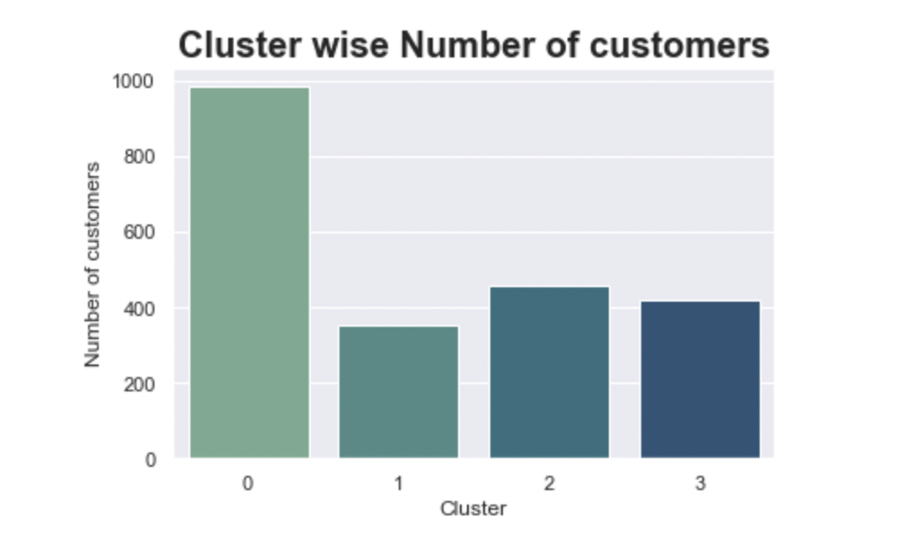

**The above count plot shows that cluster 0 covers large part of customers followed by cluster 2.**

**Scatter Plot: Income Spend Trend among clusters- Chart 22**

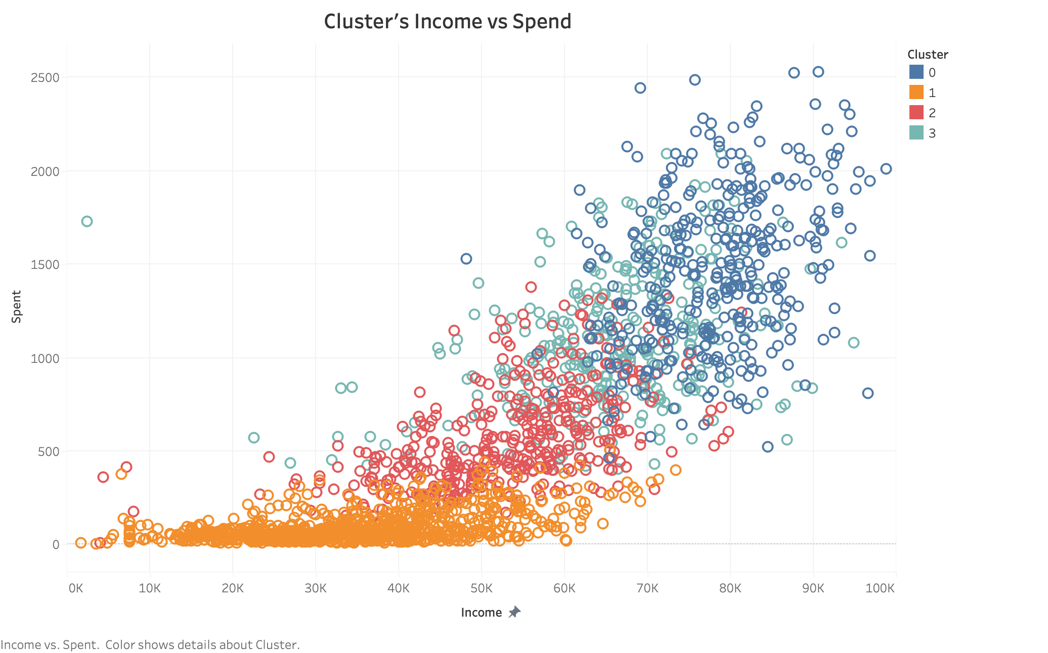

**Cluster 0 are high spenders and earn big bucks.**

**Pair bar chart: Education categorization in clusters- Chart 23**

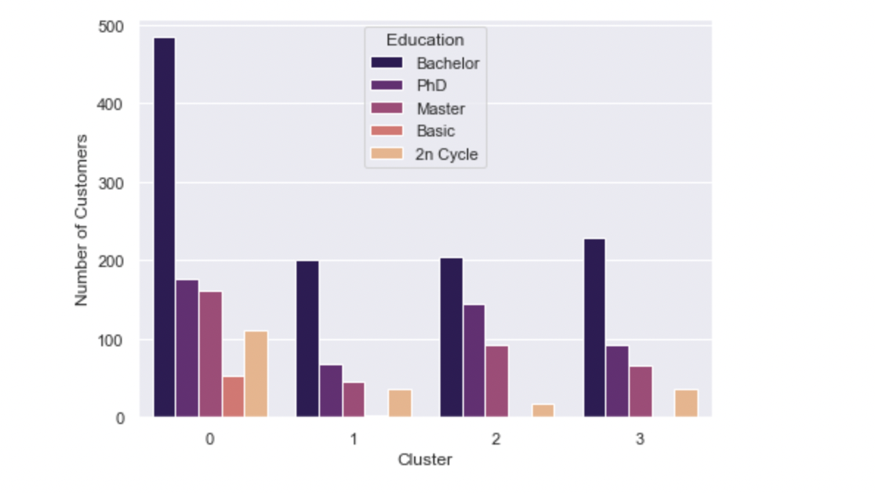

**Pair bar chart: Marital status in clusters- Chart 24**

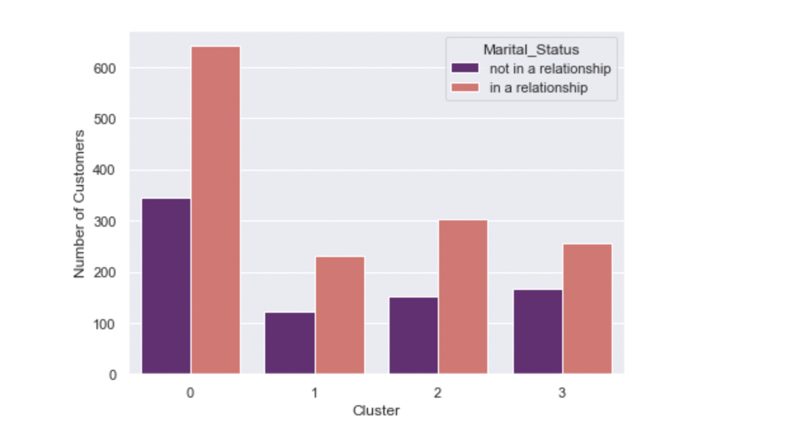

**Pair bar chart: Clusters categorized by Customer Numbers with and without children - Chart 25**

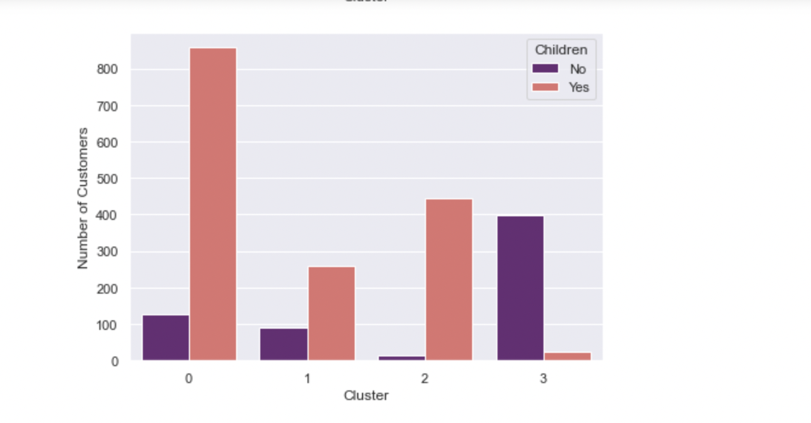 **Pair bar chart: Cluster wise purchase Forums- Chart 26**

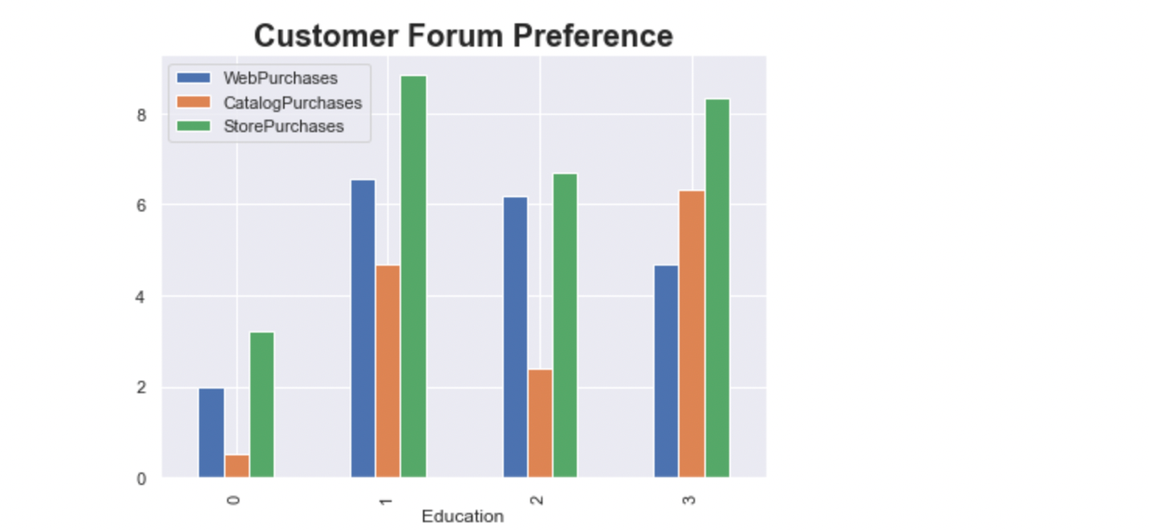

**Bar chart: Discount purchases among clusters- Chart 27**

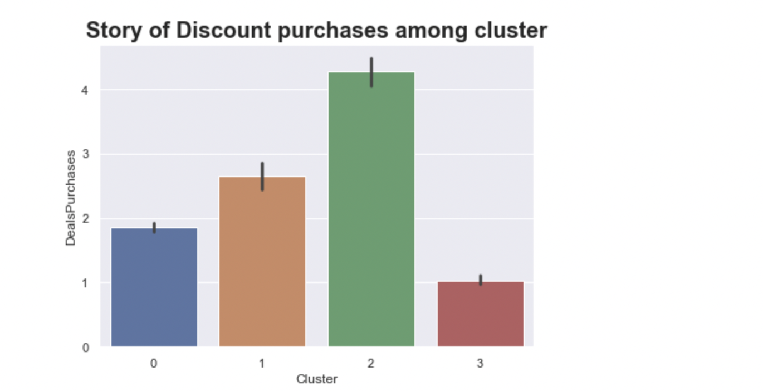**Bar chart: Recent customers in clusters- Chart 28**

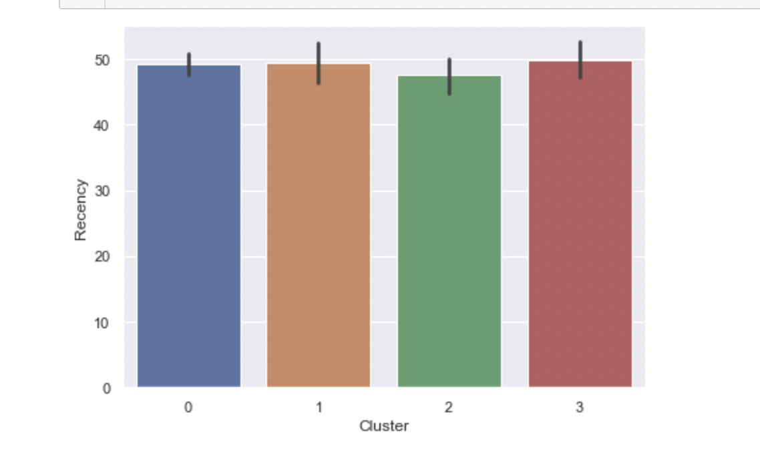

**Bar chart: Web visit stats in clusters- Chart 29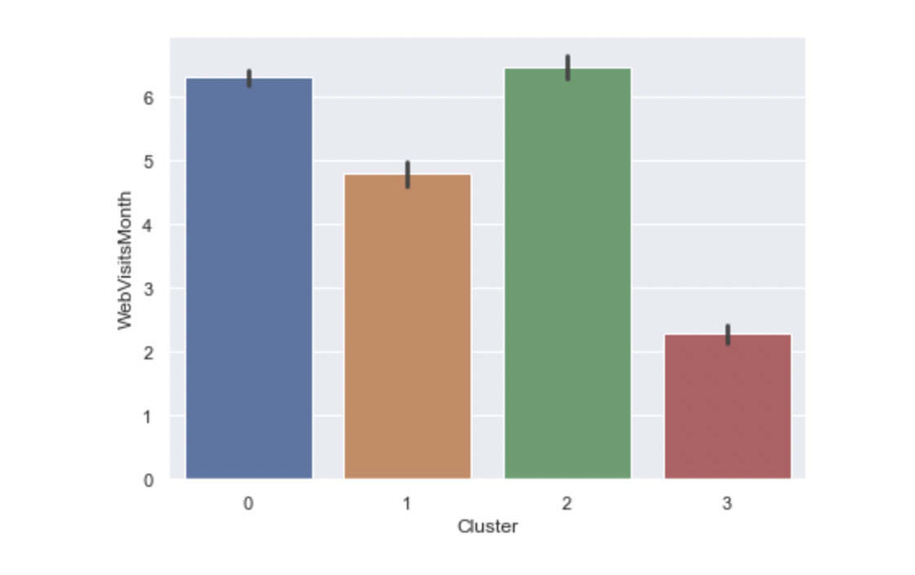 Bar chart: Complaining Customers- Chart 30**

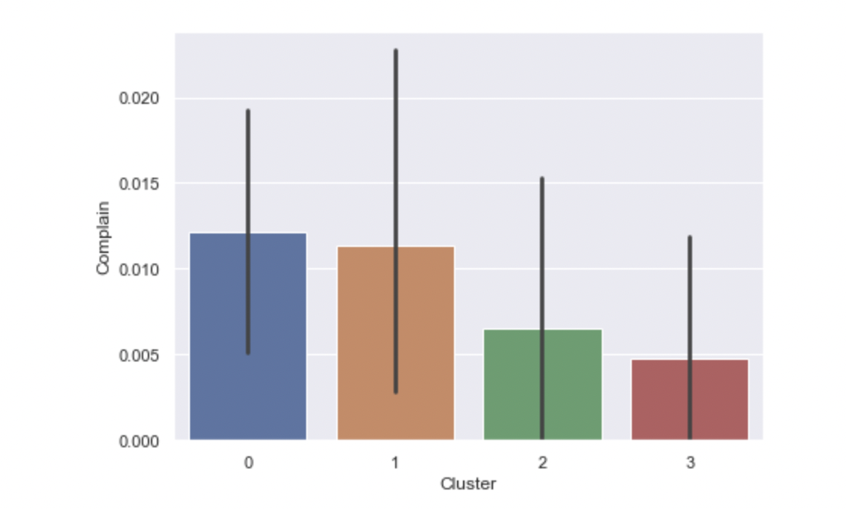

**Bar chart: Customer Loyalty- Chart 31**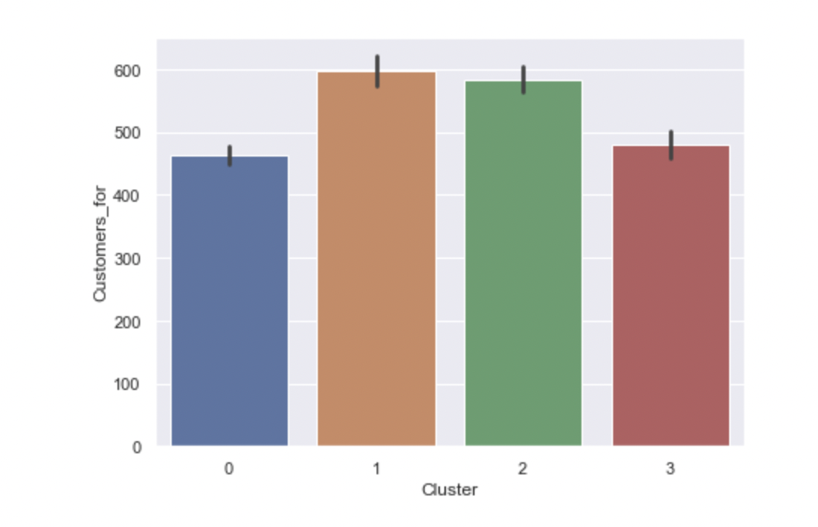

**Pair bar chart: Cluster wise commodity preferences- Chart 32**

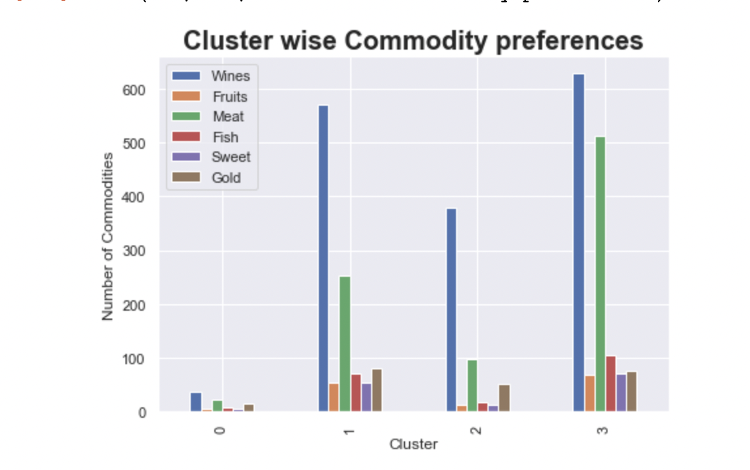

**Network graph: Youth: Product preferences- Chart 33**

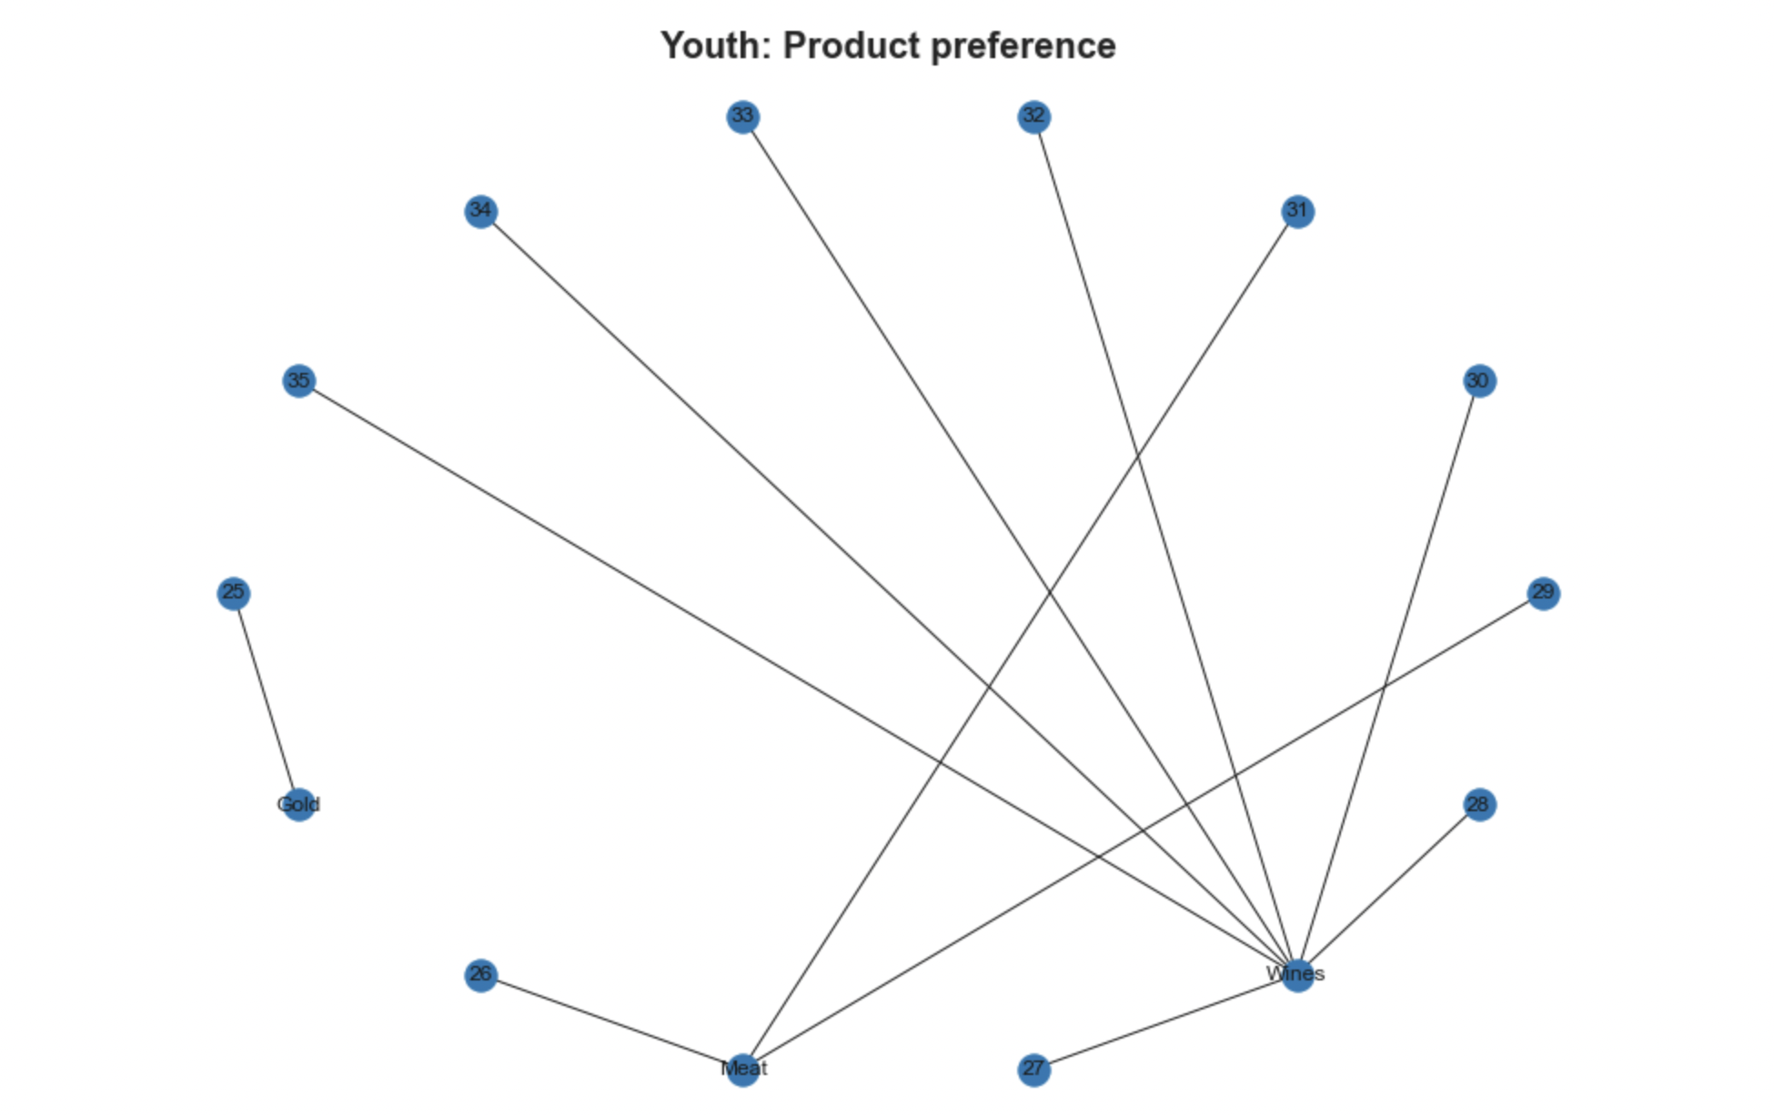

**Network graph: Middle Age: Product preferences- Chart 34**

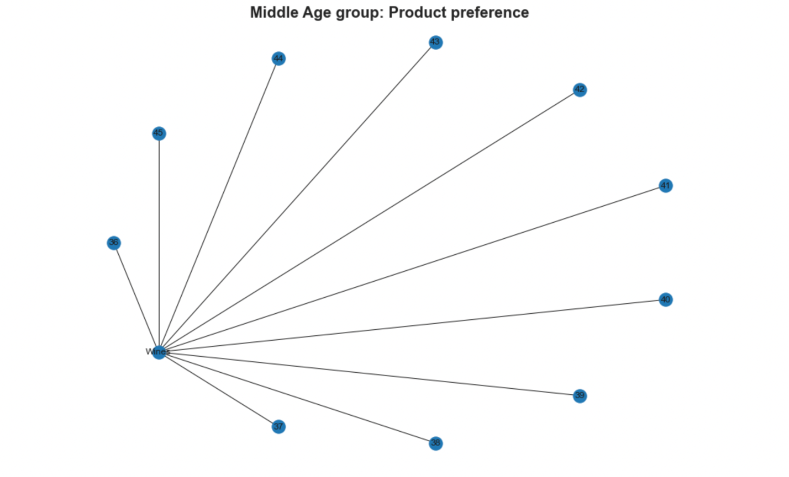

**Network graph: Upper-Middle Age: Product preferences- Chart 35**

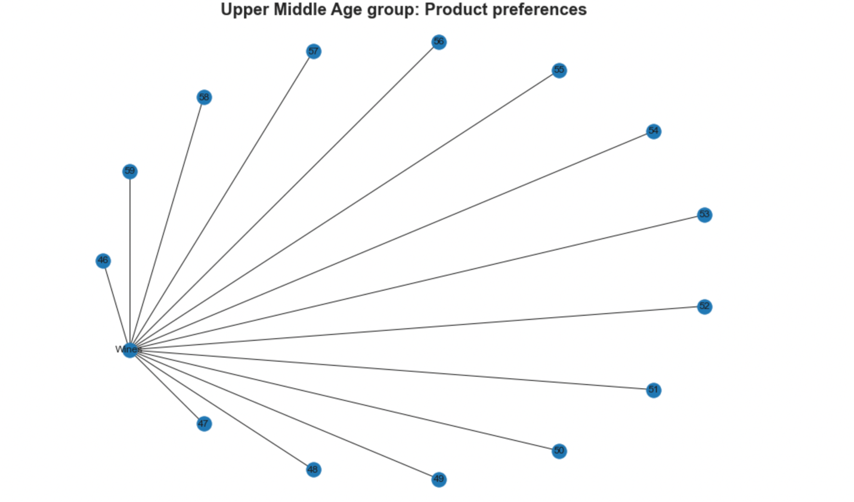 **Network graph: Senior Adult: Product preferences- Chart 36**

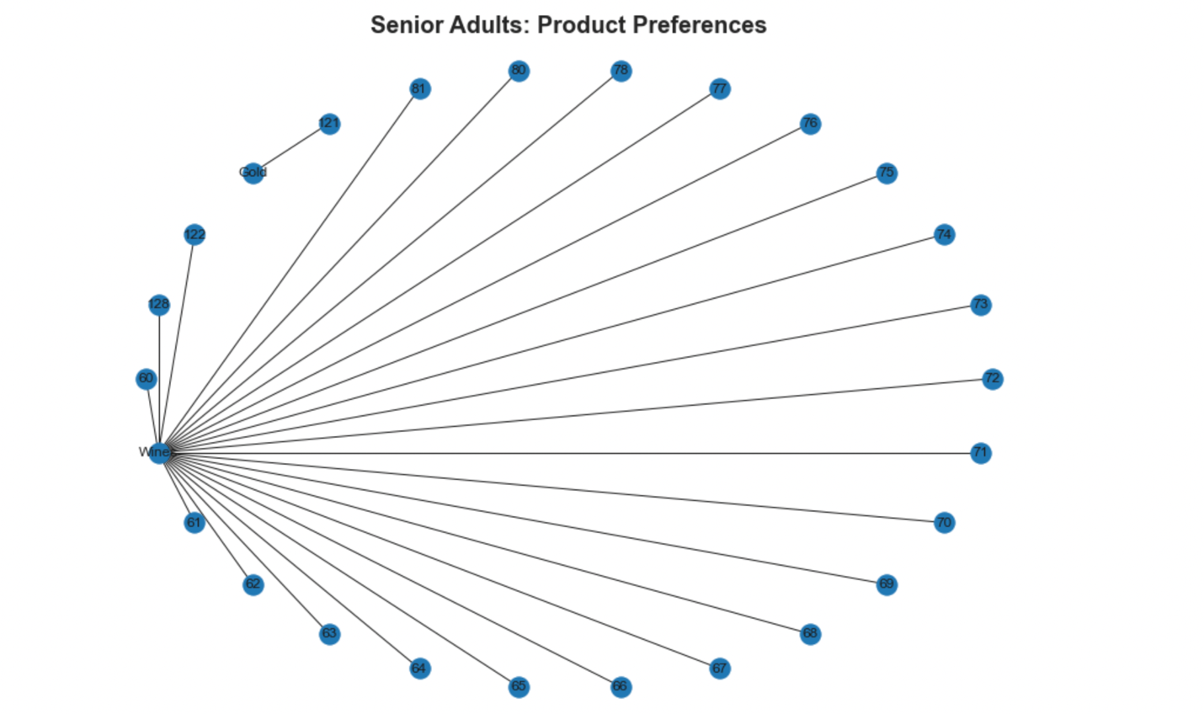

**Network graph: Youth: Forum preferences- Chart 37**

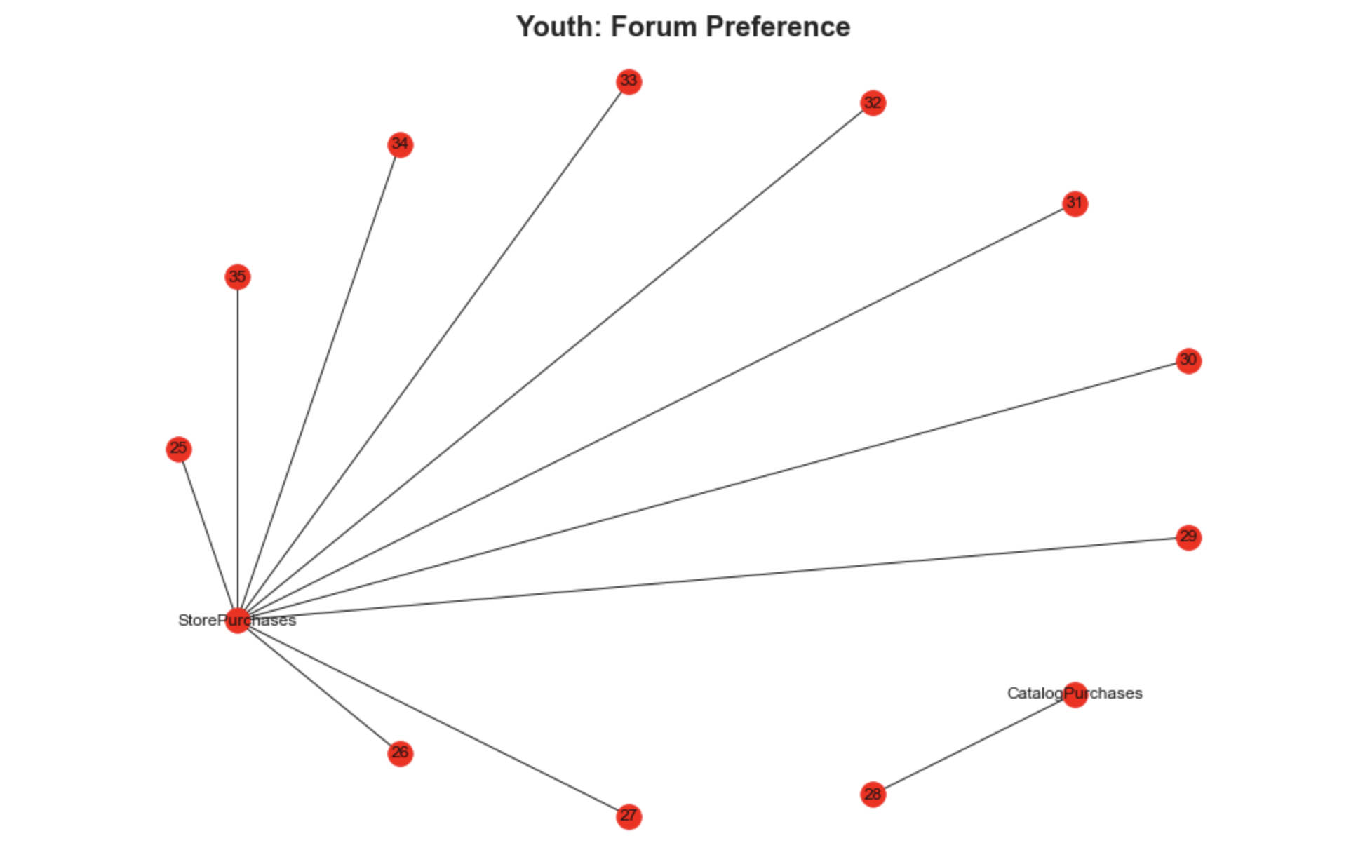 **Network graph: Middle Age: Forum preferences- Chart 38**

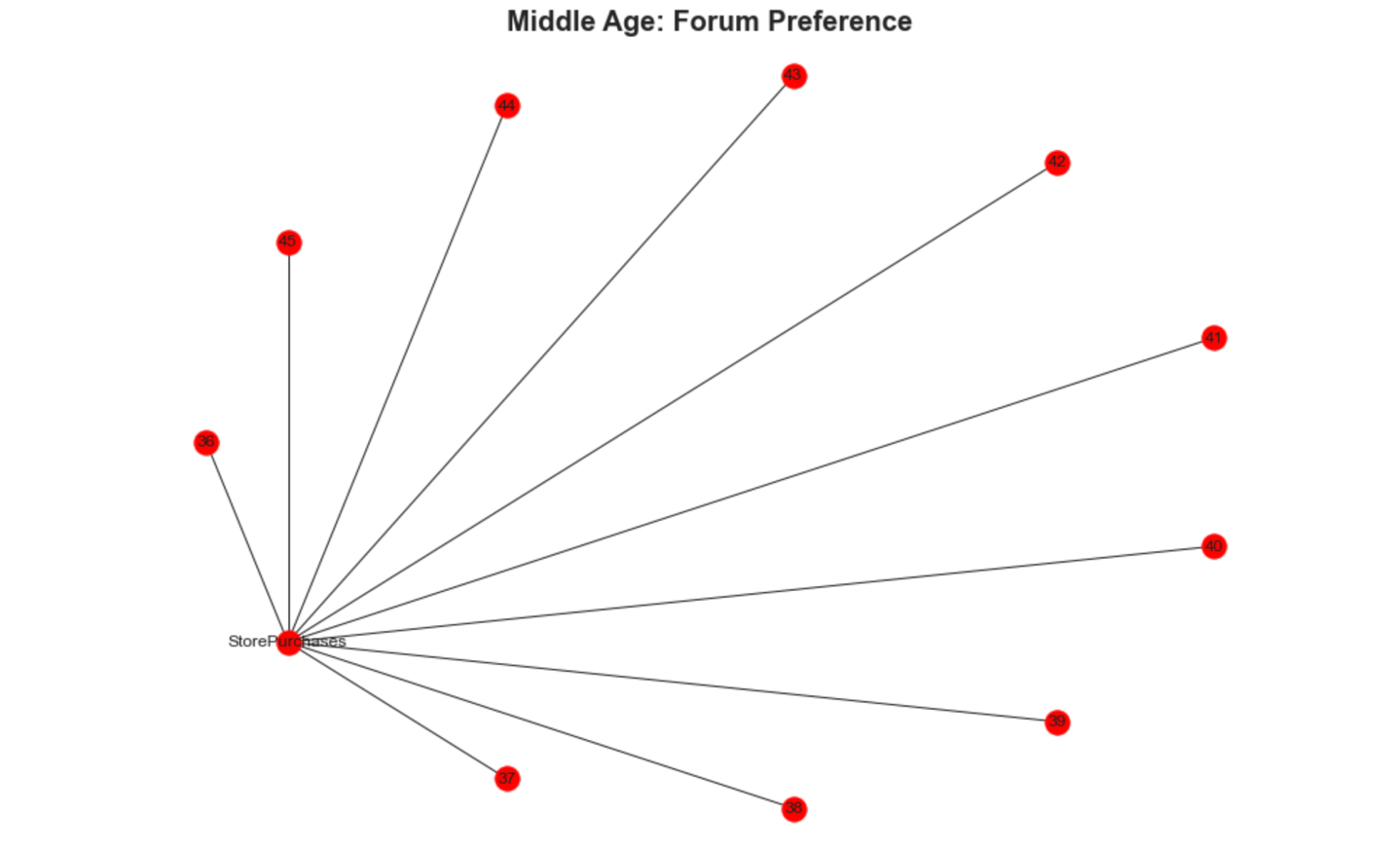

**Network graph: Upper-Middle Age: Forum preferences- Chart 39**

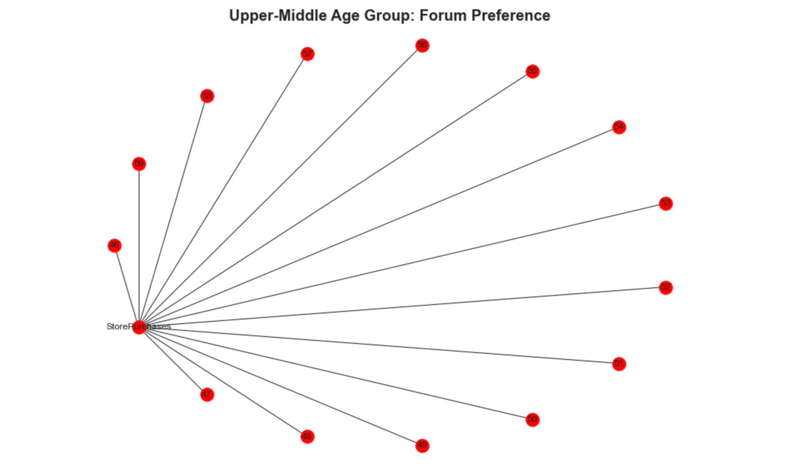

**Network graph:Senior Adult: Forum preferences- Chart 40**

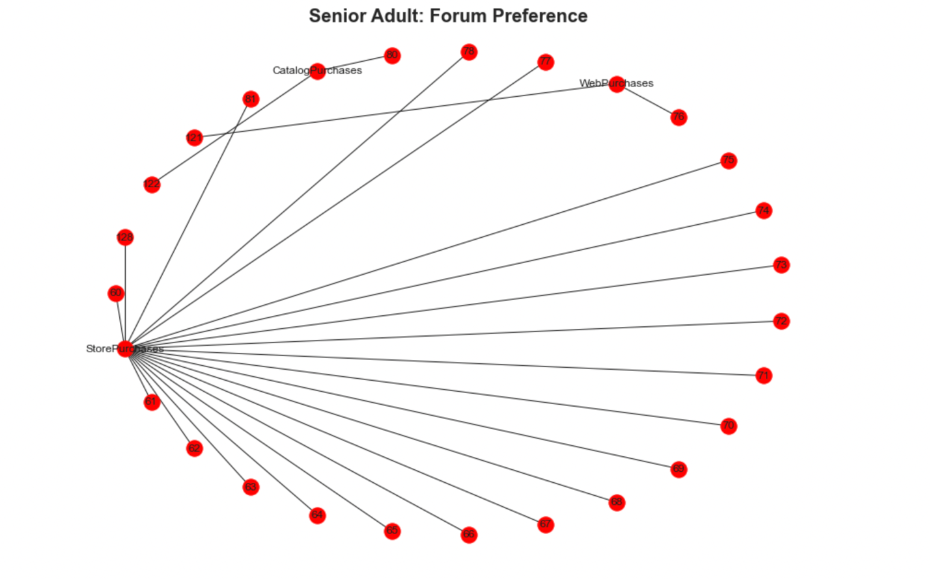

**Network graph: Product preferences of clusters- Chart 41**

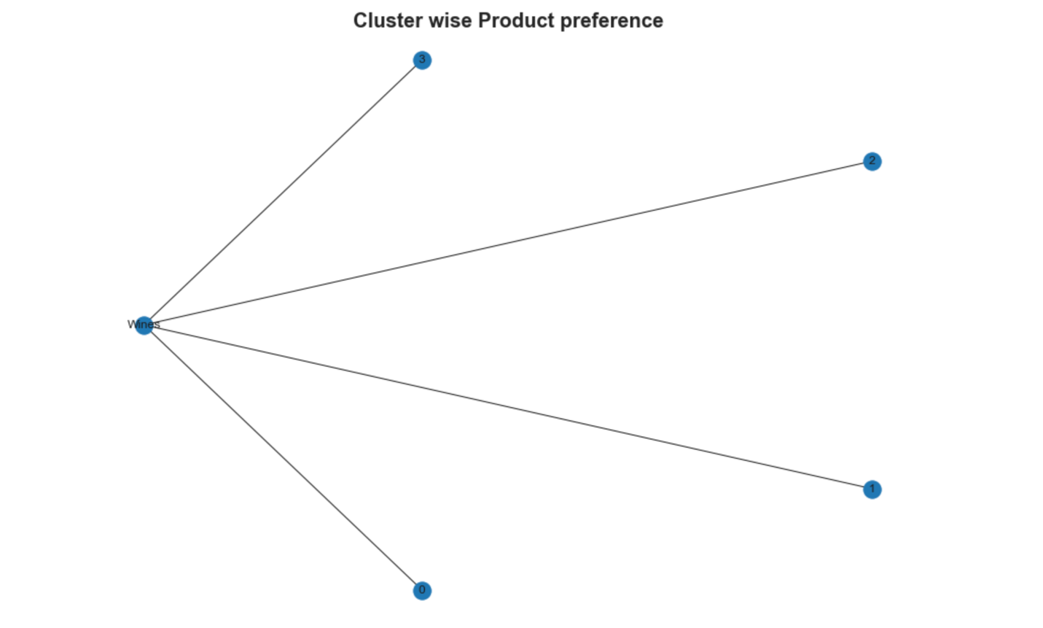

**Network graph:Forum preferences of clusters- Chart 42**

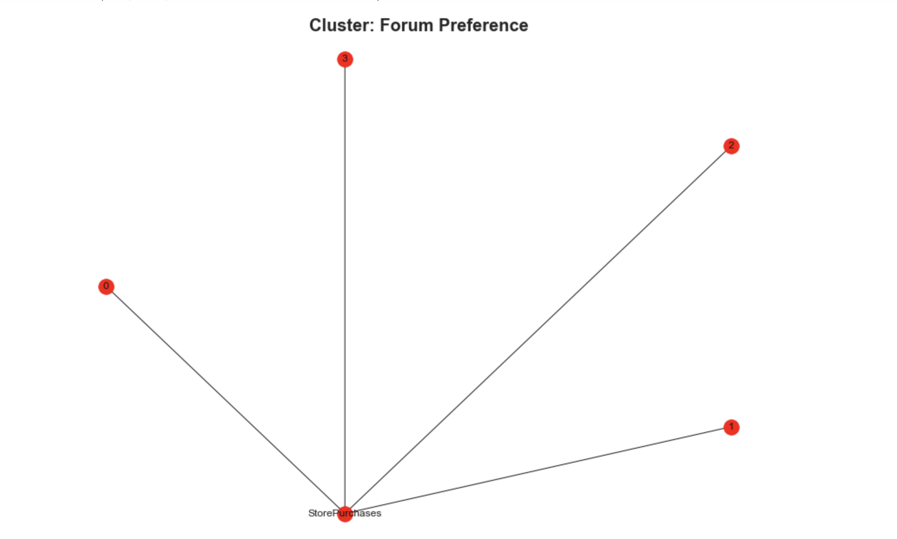

**We can study the Product preference of the cluster from the above side by side bar graph.**

**We can similarly study their income and spend trends and perform profiling of clusters. For instance, a profile can be high income, high spend category who have product preference on Wine, Gold but sweet might be their not so preferred commodity. They might have a PhD as their educational background who would like to order online.**

**Density plots can be used to show how age is distributed cluster wise.**

**Density plot:Age of cluster- Chart 43**

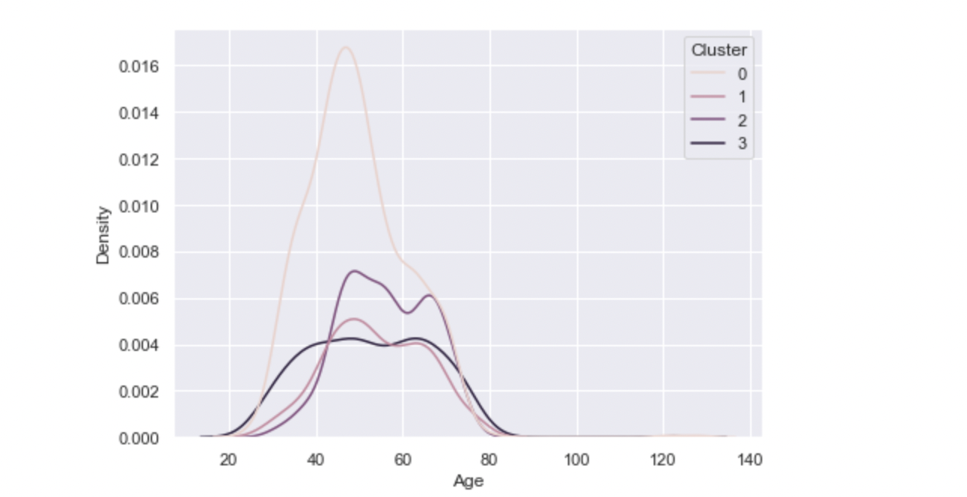

**The above is a random density chart of cluster.**

**K-Means clustering and study of different variables discussed above can help the company understand their customer. Knowing specific customer preferences and choices, income and spend trends can help companies customize their products and perform target marketing which enables advertisement cost cutting. It is a win-win situation where consumer gets what he wants and is not annoyed by irrelevant campaign and company gets boost in sale even with expenditure cut- A good business.**

**Conclusion:**

**The Cluster 0**

1. Cluster 0 covers large chunk of customers for this company.

2. It is observed that cluster 0 are moderate to high income, moderate to high spend group

3. Cluster 0 have highest numbers of those in relationship and have children and have highest bachelor degree holders

4. They general purchase instore.

5. Cluster 2 followed by cluster 0 make the highest company website hits.

6. They purchase significantly less in number and don’t have wide range of preferences.

7. Since, customer 0 are high in number they complain a lot. They purchase less. Probably cluster 0 has less customer satisfaction. Overall, this company gives better customer satisfaction as customers complain less

**Cluster 3**

1. Highest but 1 buy and highest but 1 spend category.
2. Wide range of product preferences. –prefer variety-Making them a potential area for various product line sale-The experimentative group
3. They visit the company frequently for products.
4. They are least complainers and don’t wait for discounts.

**Cluster 1**

1. They are classic example of experimentative group. They have wide range of product preferences
2. They have low income and spend relatively low.
3. They can be targeted for web purchases (ecomerce–potential forum)

**Observation**

1. All the clusters make highest instore purchases and consume wine in significantly large amounts
2. Cluster 1 followed by cluster 3 are highest store purchasers
3. Cluster 2 does a lot of discounts purchasing
4. All of them frequent to the company for products.
5. Cluster 1 and 2 have been longer with the company.

6. Cluster 3 and Cluster 1 have wide range product preferences.

7. Cluster 1 and 2 can be targeted for web purchase.

**Potential Areas**

Potential Target group: Cluster 0- because they are highest in number with higher spend capacity. They are also the highest complainers, have relatively younger relationship with company.

Potential Forum: Web. This company should explore e-commerce- Heavy save on company’s overheads.

Cluster 1 has high appetite for wide range of products. Posturing should be aligned to satisy cluster 1 (low income-spend). They can be the source of review for wide range of products. _Test group

Cluster 3 the second highest income-spend group is one of the potential areas. They complain less, generally don’t have children, consume wine heavily.

**Focus on cluster 0 (highly potential) and web purchases.**

**Future Scope of Project**:

Some more information on geographic and psychographic data (like data on Impulsive or planned buyers. Customer biases) would have given more insights.